**FASHION WORLD(Website for online shopping)**

**A Project Report**

Submitted in partial fulfillment of the Requirements for the Semester 6

## BACHELOR OF SCIENCE (INFORMATION TECHNOLOGY)

**By**

**CHAUDHARI AYESHA WAJA NIDA**

Seat No: **IT-16-3321(24)**

**IT-16-3461(23)**

**Under the esteemed guidance of**

**Mrs. Misbah Momin**

## Assistant Professor

**DEPARTMENT OF INFORMATION TECHNOLOGY**



#### ACADEMIC YEAR 2018-19

**PROJECT APPROVAL**

PNRNo.:…………………… Rollno: IT-16-3461(23)

* Name of the Student Waja Nida Akhlaque
* Title of the Project FASHION WORLD(website for online shopping)
* Name of the Guide Mrs. Misbah Momin
* Teaching experience of the Guide 10+ Years
  + Is this your first submission? Yes No

Signature of the Student Signature of the Guide

Date:………………….... Date:...........................

Signature of the IT Incharge

Date: …………………....

**DEPARTMENT OF INFORMATION TECHNOLOGY**



**CERTIFICATE**

This is to certify that the project entitled, "**FASHION WORLD(Website for online shopping)**", is bonafied work of **WAJA NIDA AKHLAQUE** bearing Seat. No: **IT-16-3461(23)**

Submitted in partial fulfillment of the requirements for the Semester 6 of BACHELOR OF SCIENCE in INFORMATION TECHNOLOGY from University of Mumbai.

**Internal Guide IT Incharge**

**External Examiner**

**Date: College Seal**

# ABSTRACT

This project is an online shopping website. It has various categories of shopping in the website .The categories are Men, Women, and Kids. These category includes Men— TopWear, BottomWear, Fashion accessories. Women--- Indian Fusion Wear, Western Wear, Jewellery, Beauty and Personal Care and Kids. It is responsive website the customer can access it from its mobile, desktop pc , laptop and various devices .

The payment option has Cash on delivery option. The customer get the Email notification on delivery of product and payment .The customer can shop from sitting any where it will save time and energy of the people. It will be having various details of the product the quality, price, no of stock of product, etc. The customer once register to website can login another time whenever needed. It is a user friendly website. It has a cart option the customer first put the product on cart, any number of product can be added on cart then customer proceed to the checkout and fill the details. The customer can make their own wishlist and further lookout for the shopping reference.

The admin can Signup / Login from the customer’s site to the dashboard using its personal username and password. Admin has the right to modify, add, delete product according to the requirement from the dashboard. Home page includes various attractive sliders that attracts our customer.

# ACKNOWLEDGEMENT

The success of this project to a number of people who are directly indirectly linked to the project work which is stretched over a period of more than a year . However would like to acknowledge the efforts of a certain few whose contribution has been instrument in the project.

I would like to thank my project guide Mrs. Misbah Momin who has had full faith in the project I choose and also for showing his complete faith in my potential to develop this project. Her involvement right from conceptualization of the study through its execution.

I owned a deep sense of gratitude’s to my project guide Mrs. Misbah Momin for simulating my interest in the subject. I would also like to thanks to our IT incharge Ms. Nusrat Ansari for her well-being and special support.

I would like to thanks to the staff of IT Department who gave the permission to use the required equipment and the necessary materials to complete the project of “FASHION WORLD”.

A special thanks to my group member Chaudhari Ayesha for always supporting my efforts and last but not the least I appreciate guidance given by other supervisor as well as the lab assistants.

# DECLARATION

I hereby declare that the project entitled**, “FASHION WORLD”** done at **GM MOMIN WOMEN’S COLLEGE**, has not been in any case duplicated to submit to any other university for the award of any degree. To the best of my knowledge other than me, no one has submitted to any other university.

The project is done in partial fulfillment of the requirements for the semester 6 of

**BACHELOR OF SCIENCE (INFORMATION TECHNOLOGY)** to be submitted

as Semester 6 project as part of our curriculum.

**Name and Signature of the Student**

# TABLE OF CONTENTS

### CHAPTER 1: INTRODUCTION

* 1. Introduction
  2. Background of Online Shopping Scenario in India
  3. Chart
  4. Objectives Of System
  5. Purpose Of System
  6. Scope Of System
  7. Applicability Of System

**CHAPTER 2: SURVEY OF TECHNOLOGY**

* 1. WordPress
     1. Benefits of using WordPress
     2. Reason for selecting WordPress technology
  2. PHP
     1. Overview
     2. History
  3. MySql
     1. Overview
     2. History

**CHAPTER 3: SYSTEM ANALYSIS**

* 1. Existing system
  2. Proposed system
     1. The proposed system implementation
  3. Requirement specification
  4. Scheduling of project
  5. Hardware used
  6. Software used
  7. Conceptual Models

**CHAPTER 4: SYSTEMDESIGN**

* 1. Design
     1. Design goals
  2. DFD for online shopping website
  3. Description of architectural design
  4. Procedural/modular approach
  5. Flow chart of system
  6. User side function
  7. Admin side function
  8. Use case diagram for online shopping system
  9. Zero level DFD—online shopping system
  10. User interface(UI)

**CHAPTER 5: IMPLEMENTATION AND TESTING**

* 1. Implementation approaches
     1. Algorithm for testing approach
     2. Coding details and code efficiency
  2. Testing Approach
     1. Unit testing
     2. Integration testing
  3. Test cases

**CHAPTER 6: RESULTS AND DISCUSSION**

* 1. Results and Challenges
  2. Test report
  3. User documentation
     + Admin—Add new product
     + Admin---All products
     + Admin---Product category
     + Admin---Order detail page
     + Admin---Orders page
     + Admin---Coupon
     + Home page
     + Men category
     + Women category
     + Kids category
     + Contact Us
     + Wishlist
     + Cart
     + Login and Signup
     + Forgot password page
     + Order configuration page

**CHAPTER 7: CONCLUSION AND FUTURE WORK**

* 1. Conclusion
  2. Limitation
  3. Scope for future work

**CHAPTER 8: REFERENCES**

**CHAPTER 1** **INTRODUCTION**

* 1. **INTRODUCTION**

**Fashion World**

The "Online Shopping System" has been developed to override the problems prevailing in the practicing manual system. These website is supported to eliminate and in some cases reduce the hardship face by these existing system. Moreover this system is designed for the particular need of the company to carry out operations in a smooth and effective manner.

This is design to assist in strategic planning ,and will help you ensure that your organization is equipped with the right level of information and details for your future goals .Also for those busy executive who are always on the go ,our system come with remote access feature, which will allow you to manage your workforce anytime ,at all times. This systems will ultimately allow you to better manage resources.

Online customers must have access to the Internet and a valid [method of payment](https://en.wikipedia.org/wiki/Online_shopping#Payment) in order to complete a transaction. Generally, higher levels of education and personal income correspond to more favorable perceptions of shopping online. Increased exposure to technology also increases the probability of developing favorable attitudes towards new shopping channels.

* 1. **BACKGROUND OF ONLINE SHOPPING SCENARIO IN INDIA**

In past few years innovation in technologies relating to telecommunications has resulted in changes in many facets of our lives including the way of information searching, the way we make a booking for our travel plans and the way we buy products or services. Today undoubtedly purchasing through conventional brick and mortar retail stores is preferred, but along with it e-commerce or electronic commerce is spreading its roots as an alternate mode for shopping in India. The most popularly known form of e-commerce or electronic commerce is online shopping. The spread of e-commerce industry today is found around the world. Presently the Asia-Pacific region is becoming the leader of the e-commerce industry with 33percent of the global market in 2015 which will reach to over 37 percent in 2018.

In Asia Pacific region China is the country with largest e-commerce market in the world. India comes after China at the second position. Recent statistics have shown that sales revenues generated through Indian e-retailing sector (Annexure B-1) have grown extremely high from 2012, from a value of 2.3 billion U.S. dollars to an estimated 17.5 billion U.S. dollars in 2015, representing a growth equal to eight times. In parlance with contribution in overall sales of Indian retail sector, the Indian e-retailing segments contribution is equal to 0.9 percent of overall to reach up to 1.4 percent in 2018. The e-commerce market of India is considered as one of the fastest-growing.

With reference to latest trends running in Indian online market according to report produced by sokrati.com in June 2016 Indian men shop online three times more than Indian women. Among the payment modes offered the most preferred one is cash on delivery by Indian shoppers. Indian e-shoppers majorly purchase clothing and accessories .After it is mobile accessories. The majority of purchase orders are placed during business hours only. Awareness about it is found more in metros or tier-I cities as compared to tier-II & III cities.

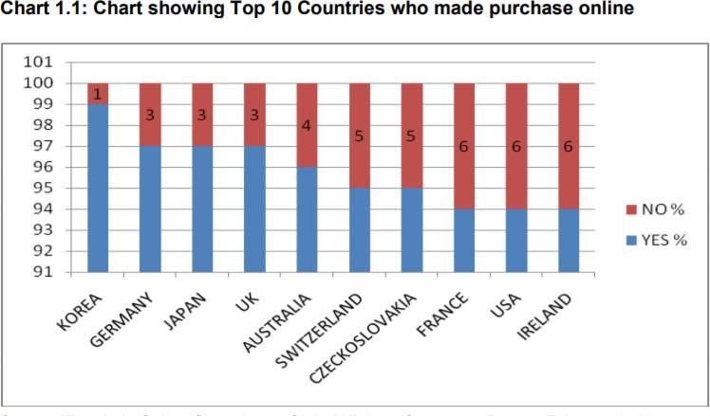

## CHART SHOWING CATEGORIES OF PRODUCTS PURCHASED ONLINE

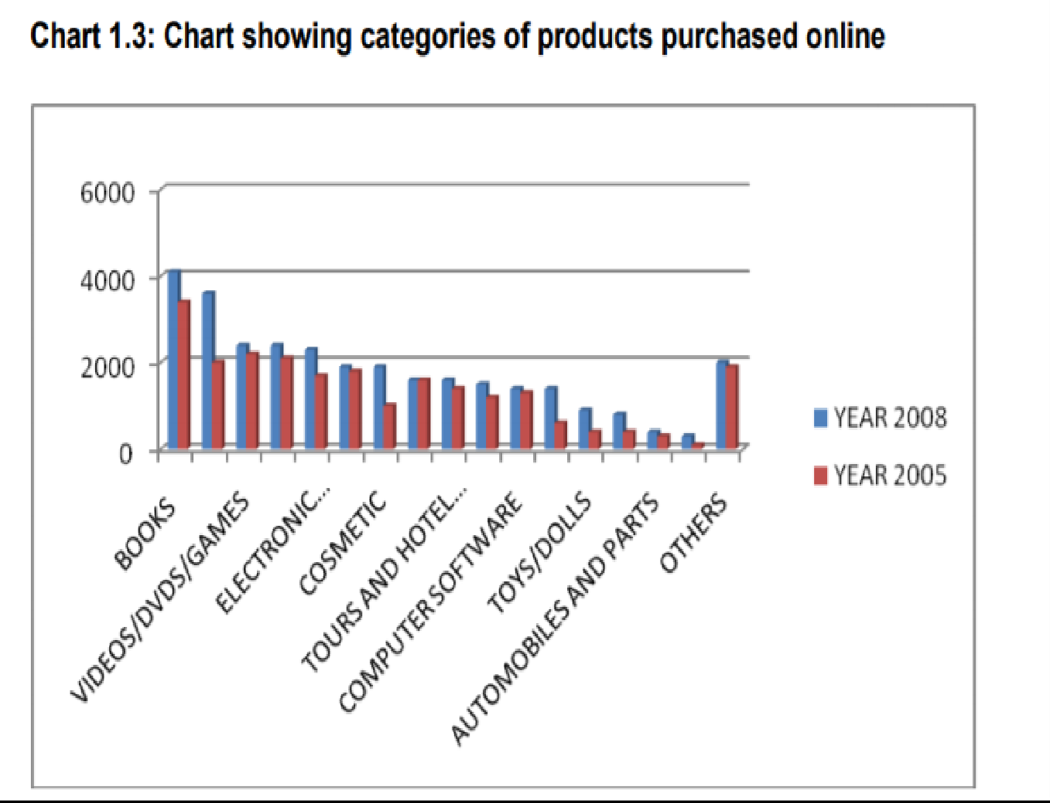

#### FASHION WORLD

* 1. **OBJECTIVES OF SYSTEM**

The main objective of the project on online shopping system is to manage the details of shopping, product, internet, payment, customer. It manages all the information about shopping, delivery, customer, shopping. The project is totally built at administrative end and thus only the administrator is guaranteed to access.

Now individuals are finding it difficult to shop from traditional channels due to their changed lifestyle. As a result of all these issues along with the technological advancements, a new mode of shopping i.e. online shopping also called as electronic shopping has emerged. The Internet, in the field of shopping, has brought sea changes in the mindset of customers with reference to convenience, speed, price, product information and services associated with online shopping.

## PURPOSE OF SYSTEM

The purpose of the project is to build an application program to reduce the manual work for managing the shopping, product, delivery, internet. It tracks all the details about the Internet, payment, customer.

While shopping online, every customer desires convenience, speed, price benefits, product comparison facility etc. It is not that these features are not available in traditional shopping methods. But due to changes in life style, the notions of these features have changed among the buyers.

#### FASHION WORLD

* 1. **SCOPE OF SYSTEM**

Every organization whether big or small, has challenges to overcome and managing information of product, shopping, payment ,delivery, customer. Every online shopping system has different shopping needs therefore we design exclusive website management systems that are adapted to your managerial requirements.

Our project aims at business process automation, i.e. we have tried to computerize various processes of online shopping system.

* + - It satisfy the user requirement.
    - Be easy to understand by the user and operator
    - Have a good user interface.

The internet has provided marketers with a completely new way to create value for customers and build relationships with them' in the form of online shopping. Online shopping is the process whereby consumers directly, without an intermediary service, buy goods or services from a seller in real-time over the Internet. One way of doing electronic commerce is online shopping. In online shopping, electronically the sale or purchase of transaction takes place 1 . It is also referred to as e-shopping where ‘e’ stands for Electronic Shopping. Electronic shopping is defined as a computer activity/exchange performed by a consumer, via a computer-based interface, where the consumer's computer is connected to and can interact with, a retailer's digital storefront to purchase the products or services over the internet.

## APPLICABILITY OF SYSTEM

There exists a large amount of differences between online and offline shopping channel. The biggest being the intangibility of online shopping channel. In spite this barrier a large portion of the population is accepting this mode of shopping because of below-mentioned advantages.

Online stores are usually available 24 hours a day, and many consumers have Internet access both at work and at home. Other establishments such as internet cafes and schools provide internet access as well. In contrast, visiting a conventional retail store requires travel and must take place during business hours.

**Convenience**: Empirical research shows that convenient of the internet is one of the impacts

On consumers’ willingness to buy online .Online shopping is available for customers around the clock comparing to traditional store as it is open 24 hours a day, 7 days a week.

**Information:** The internet has made the data accessing easier (Wang et al., 2005). Given customers rarely have a chance to touch and feel product and service online before they make decision,

online sellers normally provide more product information that customers can use when making a purchase.

**Cost and time efficiency:** Because online shopping customers are often offered a better deal, they can get the same product as they buy at store at a lower price. Since online stores offer customers with variety of products and services. it gives customers more chances to compare price from different websites and find the products with lower prices than buying from local retailing stores.

# CHAPTER 2 SURVEY OF TECHNOLOGY

## WORDPRESS

WordPress is a [free and open-source](https://en.wikipedia.org/wiki/Free_and_open-source_software) [content management system](https://en.wikipedia.org/wiki/Content_management_system) (CMS) based

on [PHP](https://en.wikipedia.org/wiki/PHP) and [MySQL.](https://en.wikipedia.org/wiki/MySQL) Features include a [plugin architecture](https://en.wikipedia.org/wiki/Plug-in_(computing)) and a [template system](https://en.wikipedia.org/wiki/Web_template_system). It is most associated with [blogging,](https://en.wikipedia.org/wiki/Blog) but supports other types of web content including more

traditional [mailing lists](https://en.wikipedia.org/wiki/Electronic_mailing_list) and [forums,](https://en.wikipedia.org/wiki/Internet_forum) media galleries, and online stores. Used by more than 60 million websites, including 30.6% of the top 10 million websites as of April 2018, WordPress is the most popular [website](https://en.wikipedia.org/wiki/Website) management system in use. WordPress has also been used for other application domains such as [pervasive display systems](https://en.wikipedia.org/wiki/Digital_signage) (PDS).

WordPress was released on May 27, 2003, by its founders, [Matt Mullenweg](https://en.wikipedia.org/wiki/Matt_Mullenweg) and [Mike Little,](https://en.wikipedia.org/wiki/Mike_Little) as a [fork](https://en.wikipedia.org/wiki/Fork_(software_development))of *b2/cafelog*. The software is released under the [GPLv2](https://en.wikipedia.org/wiki/GNU_General_Public_License#Version_2)(or later) license.

WordPress has a [web template system](https://en.wikipedia.org/wiki/Web_template_system) using a [template processor.](https://en.wikipedia.org/wiki/Template_processor) Its architecture is a [front](https://en.wikipedia.org/wiki/Front_controller) [controller,](https://en.wikipedia.org/wiki/Front_controller) routing all requests for non-static [URI](https://en.wikipedia.org/wiki/Uniform_Resource_Identifier)s to a single PHP file which parses the URI and identifies the target page. This allows support for more human-readable [permalinks.](https://en.wikipedia.org/wiki/Permalink)

#### Overview

"WordPress is a factory that makes webpages" is a core analogy designed to clarify what WordPress is & does. It stores your content that allows you to create & publish webpages only requiring a domain and a hosting site to work.

#### Plugins

WordPress' [plugin](https://en.wikipedia.org/wiki/Plugin_(computing)) architecture allows users to extend the features and functionality of a website or blog. As of February 2019, WordPress.org has 54,402 plugins available,[[19]](https://en.wikipedia.org/wiki/WordPress#cite_note-19) each of which offers custom functions and features enabling users to tailor their sites to their specific needs. However, this does not include the premium plugins that are available (approximately 1,500+), which may not be listed in the WordPress.org repository. These customizations range from [search engine](https://en.wikipedia.org/wiki/Search_engine_optimization) [optimization,](https://en.wikipedia.org/wiki/Search_engine_optimization) to [client portals](https://en.wikipedia.org/wiki/Client_portal) used to display private information to logged in users, to content management systems, to content displaying features, such as the addition of [widgets](https://en.wikipedia.org/wiki/GUI_widget) and [navigation](https://en.wikipedia.org/wiki/Navigation_bar) [bars.](https://en.wikipedia.org/wiki/Navigation_bar) Not all available plugins are always abreast with the upgrades and as a result they may not function properly or may not function at all. Most plugins are available through WordPress themselves, either via downloading them and installing the files manually via FTP or through the

#### FASHION WORLD

WordPress dashboard. However, many third parties offer plugins through their own websites, many of which are paid packages.

|  |  |
| --- | --- |
| **PLUGINS** | **DESCRIPTION** |
| Contact form 7 | Contact form plugin and it is flexible |
| Gmail SMTP | Easily send email from our WordPress site via Gmail SMP server |
| Mailchimp for WordPress | Used for sign-up methods in our sites |
| Perfect WooCommerce brands | Used to show brand based on WooCommerce store |
| Slide anything | Used for sliders |
| WooCommerce | Ecommerce toolkit to sell anything |
| YITH WooCommerce Wishlist | Used by users to create a Wishlist in a website |

#### Themes

WordPress users may install and switch among different [themes.](https://en.wikipedia.org/wiki/Theme_(computing)) Themes allow users to change the look and functionality of a WordPress website without altering the core code or site content. Every WordPress website requires at least one theme to be present and every theme should be designed using WordPress standards with structured [PHP](https://en.wikipedia.org/wiki/PHP), valid [HTML](https://en.wikipedia.org/wiki/HTML) (Hyper Text Markup Language), and [Cascading Style Sheets](https://en.wikipedia.org/wiki/Cascading_Style_Sheets) (CSS). Themes may be directly installed using the WordPress "Appearance" administration tool in the dashboard, or theme folders may be copied directly into the themes directory, for example via [FTP](https://en.wikipedia.org/wiki/File_Transfer_Protocol).

The [PHP,](https://en.wikipedia.org/wiki/PHP) [HTML](https://en.wikipedia.org/wiki/HTML) and [CSS](https://en.wikipedia.org/wiki/Cascading_Style_Sheets) found in themes can be directly modified to alter theme behavior, or a theme can be a "child" theme which inherits settings from another theme and selectively overrides

#### FASHION WORLD

features.[ WordPress themes are generally classified into two categories: free and premium. Many free themes are listed in the WordPress theme directory, and premium themes are available for purchase from marketplaces and individual WordPress developers. WordPress users may also create and develop their own custom themes. The free theme Underscores created by the WordPress developers has become a popular basis for new themes.

#### Multi-User and Multi-Blogging

Prior to version 3, WordPress supported one blog per installation, although multiple concurrent copies may be run from different directories if configured to use separate database tables. WordPress Multisites (previously referred to as WordPress Multi-User, WordPress MU, or WPMU) was a fork of WordPress created to allow multiple blogs to exist within one installation but is able to be administered by a centralized maintainer. WordPress MU makes it possible for those with websites to host their own blogging communities, as well as control and moderate all the blogs from a single dashboard. WordPress MS adds eight new data tables for each blog.

As of the release of WordPress 3, WordPress MU has merged with WordPress.

#### FASHION WORLD

* + 1. **BENEFITS OF USINGWORDPRESS**

WordPress has been around since 2003 and is the most popular blogging software on the market. Over the last few years, WordPress has also become the content management software of choice for non-blogging websites. Here are the top 10 reasons why WordPress is so popular and why you might want to consider switching to a WordPress platform for your company’s website.

#### Ease of Use

WordPress is very easy to use and has an intuitive interface. Adding new pages, blog posts, images, etc. on a regular basis is a breeze and can be done quickly. Because the technology is so simple, time spent on formatting is greatly reduced.

#### Manage Our Website from Any Computer

WordPress is browser-based. We can login from any Internet connected computer and manage your site.

#### No HTML Editing or FTP Software Required

WordPress is a self-contained system and does not require HTML editing software (such as Adobe Contribute or Dreamweaver). We can create a new page or blog post, format text, upload images (and edit them), upload documents, video files, image galleries, etc. all without the need for additional HTML or FTP software.

#### Search Engines Love WordPress Sites

The code behind WordPress is very clean and simple, making it easy for search engines to read and index a site’s content. In addition, each page, post, and image can have its own meta tag keywords, description, and title, and be optimized for specific keywords, allowing for very precise search engine optimization. We can also use tags to further enhance our search engine optimization efforts.

#### FASHION WORLD

* + **We Have Control of our Site**

No more waiting for our web designer to make simple updates to our site. With WordPress, we have control of nearly every aspect of our site and can easily make those simple updates ourself.

#### The Design of Our Website is 100% Customizable

WordPress acts as the engine for our website. The look and feel of the site can be 100% customized so our brand can shine through on our site and provide a unique experience to our visitors.

#### A Blog is Built-in and Ready to Go

Since WordPress was originally created as a blogging platform, blogging capabilities are built-in and are easy to integrate, if desired. Setting up RSS / email subscriptions to our blog, commenting capabilities, and automatically adding the most recent blog posts to other pages of the site (your home page, for example) are also very simple to set-up, and help to extend our company’s reach and make our site more dynamic and interactive.

#### Extend the Functionality of Our Site with Plugins

Want to add an event calendar, video gallery, Twitter Feed, Facebook Fan Box, and more to our site? WordPress makes this possible with plugins, most of which are free or very reasonably priced.

#### Our Site Can Grow as Our Business Grows

WordPress sites are very scalable. We can have hundreds of thousands of pages or blog posts on our site and the performance of the site will not be compromised in the least.

#### Have Multiple Users

As an administrator of a WordPress site, we can set-up multiple users for the website and assign access levels and capabilities to each user.

#### FASHION WORLD

* + 1. **REASON FOR SELECTING WORDPRESS TECHNOLOGY**

Due to the nature of [open source,](https://www.wpbeginner.com/glossary/open-source/) WordPress is a community software. It is maintained by a large group of volunteers majority of whom are WordPress consultants with active interest in growing and maintaining WordPress. Anyone can contribute to WordPress by writing patches, answering support questions, writing plugins, creating themes, translating WordPress and updating documentation.

By using WordPress you become part of that awesome community. You get free support from other community members, download free plugins and themes, and once you have little experience with WordPress you can even contribute back to the community.

WordPress is used by millions of people and almost every day new people are joining the WordPress community by creating their first WordPress powered websites. The reason why people quickly adapt to WordPress is because it is fairly easy to use.

#### WordPress Is Open-Source with No Software Fees

* **You Don’t Have to Be a Web Developer**
* **Designing Your Site Requires No Coding Skills**
* **If You Need Extra Functionality, There’s a Plugin For That**
* **Adding E-Commerce Is Easy With WordPress**
* **Search Engine Friendly**
* **WordPress Has a Large, Strong Community**

**FASHION WORLD**

* 1. **PHP**

**Hypertext Preprocessor** (or simply **PHP**) is a [server-side scripting](https://en.wikipedia.org/wiki/Server-side_scripting) language designed for [Web](https://en.wikipedia.org/wiki/Web_development) [development,](https://en.wikipedia.org/wiki/Web_development) but also used as a [general-purpose programming language.](https://en.wikipedia.org/wiki/General-purpose_programming_language) It was originally created by [Rasmus Lerdorf](https://en.wikipedia.org/wiki/Rasmus_Lerdorf)in 1994, the PHP [reference implementation](https://en.wikipedia.org/wiki/Reference_implementation) is now produced by The PHP Group. PHP originally stood for *Personal Home Page*, but it now stands for the [recursive acronym](https://en.wikipedia.org/wiki/Recursive_acronym) *PHP: Hypertext Preprocessor*.

PHP code may be embedded into [HTML](https://en.wikipedia.org/wiki/HTML) code, or it can be used in combination with various [web](https://en.wikipedia.org/wiki/Web_template_system) [template systems,](https://en.wikipedia.org/wiki/Web_template_system) web content management systems, and [web frameworks](https://en.wikipedia.org/wiki/Web_framework). PHP code is usually processed by a PHP [interpreter](https://en.wikipedia.org/wiki/Interpreter_(computing)) implemented as a [module](https://en.wikipedia.org/wiki/Plugin_(computing)) in the web server or as a [Common](https://en.wikipedia.org/wiki/Common_Gateway_Interface) [Gateway Interface](https://en.wikipedia.org/wiki/Common_Gateway_Interface) (CGI) executable. The web server combines the results of the interpreted and executed PHP code, which may be any type of data, including images, with the generated web page. PHP code may also be executed with a [command-line interface](https://en.wikipedia.org/wiki/Command-line_interface) (CLI) and can be used to implement [standalone graphical applications.](https://en.wikipedia.org/wiki/Computer_software)

The standard PHP interpreter, powered by the [Z end Engine,](https://en.wikipedia.org/wiki/Zend_Engine) is [free software](https://en.wikipedia.org/wiki/Free_software) released under the [PHP License.](https://en.wikipedia.org/wiki/PHP_License) PHP has been widely ported and can be deployed on most web serverson almost every [operating system](https://en.wikipedia.org/wiki/Operating_system) and [platform,](https://en.wikipedia.org/wiki/Computing_platform) free of charge.

The PHP language evolved without a written [formal specification](https://en.wikipedia.org/wiki/Formal_specification) or standard until 2014.

PHP includes various [free and open-source libraries](https://en.wikipedia.org/wiki/List_of_PHP_libraries) in its source distribution, or uses them in resulting PHP binary builds. PHP is fundamentally an [Internet](https://en.wikipedia.org/wiki/Internet)-aware system with built-in modules for accessing [File Transfer Protocol](https://en.wikipedia.org/wiki/File_Transfer_Protocol) (FTP) servers and many database servers, including [PostgreSQL](https://en.wikipedia.org/wiki/PostgreSQL), [MySQL,](https://en.wikipedia.org/wiki/MySQL) [Microsoft SQL Server](https://en.wikipedia.org/wiki/Microsoft_SQL_Server) and [SQLite](https://en.wikipedia.org/wiki/SQLite) (which is an embedded database), [LDAP](https://en.wikipedia.org/wiki/Lightweight_Directory_Access_Protocol) servers, and others. Numerous functions familiar to C programmers, such as those in the [stdio](https://en.wikipedia.org/wiki/Stdio.h) family, are available in standard PHP builds.

#### FASHION WORLD

* + 1. **OVERVIEW**

|  |  |  |
| --- | --- | --- |
| **Version** | **Release date** | **Supported until** |
| 5.5 | 20 June 2013 | 10 July 2016 |
| 5.6 | 28 **August** 2014 | 31 **December** 2018 |
| 7.0 | 3 **December** 2015 | 3 **December** 2018 |

* + 1. **HISTORY**

PHP development began in 1994 when [Rasmus Lerdorf](https://en.wikipedia.org/wiki/Rasmus_Lerdorf) wrote several [Common Gateway](https://en.wikipedia.org/wiki/Common_Gateway_Interface) [Interface](https://en.wikipedia.org/wiki/Common_Gateway_Interface)(CGI) programs in C, which he used to maintain his [personal homepage.](https://en.wikipedia.org/wiki/Personal_homepage) He extended them to work with [web forms](https://en.wikipedia.org/wiki/Web_form) and to communicate with [databases,](https://en.wikipedia.org/wiki/Database) and called this implementation "Personal Home Page/Forms Interpreter" or PHP/FI.

PHP/FI could be used to build simple, dynamic [web applications.](https://en.wikipedia.org/wiki/Web_application) To accelerate [bug](https://en.wikipedia.org/wiki/Software_bug) reporting and improve the code, Lerdorf initially announced the release of PHP/FI as "Personal Home Page Tools (PHP Tools) version 1.0" on the [Use net](https://en.wikipedia.org/wiki/Usenet) discussion

group *comp.infosystems.*[*www.authoring.cgi*](http://www.authoring.cgi/)on June 8, 1995. This release already had the basic functionality that PHP has today. This included [Perl-like variables,](https://en.wikipedia.org/wiki/Local_variable#Local_variables_in_Perl) form handling, and the ability to embed HTML. The [syntax](https://en.wikipedia.org/wiki/Syntax) resembled that of Perl, but was simpler, more limited and less consistent.

#### FASHION WORLD

* 1. **MySQL**

MySQL is an [open-source](https://en.wikipedia.org/wiki/Open-source) [relational database management system](https://en.wikipedia.org/wiki/Open-source) (RDBMS). Its name is a combination of "My", the name of co-founder [Michael Widenius'](https://en.wikipedia.org/wiki/Michael_Widenius)s daughter, and "[SQL](https://en.wikipedia.org/wiki/SQL)", the abbreviation for [Structured Query Language.](https://en.wikipedia.org/wiki/Structured_Query_Language) The MySQL development project has made

its [source code](https://en.wikipedia.org/wiki/Source_code) available under the terms of the [GNU General Public License,](https://en.wikipedia.org/wiki/GNU_General_Public_License) as well as under a variety of [proprietary](https://en.wikipedia.org/wiki/Proprietary_software) agreements. MySQL was owned and sponsored by a single [for-profit](https://en.wikipedia.org/wiki/Business) firm, the [Swedish](https://en.wikipedia.org/wiki/Sweden) company [MySQL AB,](https://en.wikipedia.org/wiki/MySQL_AB) now owned by [Oracle Corporation.](https://en.wikipedia.org/wiki/Oracle_Corporation) For proprietary use, several paid editions are available, and offer additional functionality.

MySQL is a central component of the [LAMP](https://en.wikipedia.org/wiki/LAMP_(software_bundle)) open-source web application software stack (and other "[AMP](https://en.wikipedia.org/wiki/List_of_AMP_packages)" stacks). LAMP is an acronym for "[Linux,](https://en.wikipedia.org/wiki/Linux) [Apache,](https://en.wikipedia.org/wiki/Apache_HTTP_Server) MySQL, [Perl/](https://en.wikipedia.org/wiki/Perl)[PHP](https://en.wikipedia.org/wiki/PHP)/[Python](https://en.wikipedia.org/wiki/Python_(programming_language))". Applications that use the MySQL database include: [TYPO3,](https://en.wikipedia.org/wiki/TYPO3) [MODx,](https://en.wikipedia.org/wiki/MODx) [Joomla,](https://en.wikipedia.org/wiki/Joomla) [WordPress,](https://en.wikipedia.org/wiki/WordPress) [Simple](https://en.wikipedia.org/wiki/Simple_Machines_Forum) [Machines Forum,](https://en.wikipedia.org/wiki/Simple_Machines_Forum) [phpBB,](https://en.wikipedia.org/wiki/PhpBB) [MyBB,](https://en.wikipedia.org/wiki/MyBB) and [Drupal.](https://en.wikipedia.org/wiki/Drupal) MySQL is also used in many high- profile, large- scale [websites,](https://en.wikipedia.org/wiki/Website) including [Google](https://en.wikipedia.org/wiki/Google)(though not for searches), [Facebook,](https://en.wikipedia.org/wiki/Facebook) [Twitter](https://en.wikipedia.org/wiki/Twitter), [Flickr,](https://en.wikipedia.org/wiki/Flickr) and [YouTube.](https://en.wikipedia.org/wiki/YouTube)

* + 1. **OVERVIEW**

MySQL is written in [C](https://en.wikipedia.org/wiki/C_(programming_language)) and [C++.](https://en.wikipedia.org/wiki/C%2B%2B) Its SQL parser is written in [yacc,](https://en.wikipedia.org/wiki/Yacc) but it uses a home- brewed [lexical analyzer.](https://en.wikipedia.org/wiki/Lexical_analysis) MySQL works on many [system platforms,](https://en.wikipedia.org/wiki/System_platform)

including [AIX,](https://en.wikipedia.org/wiki/AIX_operating_system) [BSDi,](https://en.wikipedia.org/wiki/BSD/OS) [FreeBSD,](https://en.wikipedia.org/wiki/FreeBSD) [HP-UX,](https://en.wikipedia.org/wiki/FreeBSD)[eComStation,](https://en.wikipedia.org/wiki/EComStation) [i5/OS,](https://en.wikipedia.org/wiki/IBM_i5/OS) [IRIX,](https://en.wikipedia.org/wiki/IRIX) [Linux,](https://en.wikipedia.org/wiki/IRIX) [macOS,](https://en.wikipedia.org/wiki/MacOS) [MicrosoftWindows,](https://en.wikipedia.org/wiki/Microsoft_Windows) [NetBSD,](https://en.wikipedia.org/wiki/NetBSD) [Novell NetWare,](https://en.wikipedia.org/wiki/Novell_NetWare) [OpenBSD,](https://en.wikipedia.org/wiki/OpenBSD) [OpenSolaris,](https://en.wikipedia.org/wiki/OpenSolaris) [OS/2](https://en.wikipedia.org/wiki/OS/2)Warp, [QNX,](https://en.wikipedia.org/wiki/QNX) [OracleSolaris,](https://en.wikipedia.org/wiki/Solaris_(operating_system)) [Symbian,](https://en.wikipedia.org/wiki/Symbian) [SunOS,](https://en.wikipedia.org/wiki/SunOS) [SCO OpenServer,](https://en.wikipedia.org/wiki/SCO_OpenServer) SCO [UnixWare,](https://en.wikipedia.org/wiki/UnixWare) Sanos and [Tru64](https://en.wikipedia.org/wiki/Tru64). A port of MySQL to [OpenVMS](https://en.wikipedia.org/wiki/OpenVMS)also exists.

The MySQL server software itself and the client libraries use [dual-licensing](https://en.wikipedia.org/wiki/Dual_license)distribution. They are offered under GPL version 2, beginning from 28 June 2000 (which in 2009 has been extended with a [FLOSS](https://en.wikipedia.org/wiki/Alternative_terms_for_free_software)License Exception) or to use a proprietary license.

### HISTORY

MySQL was created by a Swedish company, [MySQL AB,](https://en.wikipedia.org/wiki/MySQL_AB) founded by [David Ax mark,](https://en.wikipedia.org/wiki/David_Axmark) Allan Larsson and [Michael "Monty" Widenius.](https://en.wikipedia.org/wiki/Michael_(Monty)_Widenius) Original development of MySQL by Widenius and Ax mark began in 1994.[[26]](https://en.wikipedia.org/wiki/MySQL#cite_note-26)The first version of MySQL appeared on 23 May 1995. It was initially created for personal usage from [MySQL](https://en.wikipedia.org/wiki/MSQL) based on the low-level language [ISAM,](https://en.wikipedia.org/wiki/ISAM) which the creators considered too slow and inflexible. They created a new [SQL](https://en.wikipedia.org/wiki/Structured_Query_Language) interface, while keeping the same [API](https://en.wikipedia.org/wiki/Application_programming_interface) as MySQL. By keeping the API consistent with the MySQL system, many developers were able to use MySQL instead of the (proprietarily licensed) MySQL antecedent.

**Deployment**

MySQL can be built and installed manually from source code, but it is more commonly installed from a binary package unless special customizations are required. On most [Linux distributions,](https://en.wikipedia.org/wiki/Linux_distribution) the [package management system](https://en.wikipedia.org/wiki/Package_management_system) can download and install MySQL with minimal effort, though further configuration is often required to adjust security and optimization settings.

**High availability of Software**

Oracle MySQL offers nowadays a high availability solution with a mix of tools including the MySQL router and the MySQL Shell all based on Group Replication, open source tools.

MariaDB offers a similar offer in terms of products.

**MySQL as a Service**

Some cloud platforms offer MySQL "as a service". In this configuration, application owners do not have to install and maintain the MySQL database on their own. Instead, the database service provider takes responsibility for installing and maintaining the database, and application owners pay according to their usage. Notable cloud-based MySQL services are the [Amazon Relational](https://en.wikipedia.org/wiki/Amazon_Relational_Database_Service) [Database Service](https://en.wikipedia.org/wiki/Amazon_Relational_Database_Service); [Oracle MySQL Cloud Service,](https://cloud.oracle.com/mysql) [Azure Database for MySQL,](https://azure.microsoft.com/en-us/services/mysql/) [Rack space](https://en.wikipedia.org/wiki/Rackspace); [HP](https://en.wikipedia.org/wiki/HP_Converged_Cloud) [Converged Cloud](https://en.wikipedia.org/wiki/HP_Converged_Cloud); [Heroku](https://en.wikipedia.org/wiki/Heroku), [Elastic](https://en.wikipedia.org/wiki/Jelastic) and Scale Grid.

# CHAPTER 3 SYSTEM ANALYSIS

## EXISTING SYSTEM

The present scenario for shopping is to visit the shops and market manually and then from the available product list one needs to choose the item he or she wants and then payment for the same item mainly in cash mode is done, as not every society is well educated and aware to use net banking or card modes or wallets etc.

This system is not much user friendly as one needs to go to the market physically and then select items only from the available list. So mostly it is difficult to get the product as per our desire.

Description about the products are less available and are mostly verbal only. For this type of shopping one needs to have ample amount of free time. Also not really good markets exist everywhere, so many times good markets become out of reach for certain people.

In day to day life, we will need to buy lots of goods or products from a shop. It may be food items, electronic items, house hold items etc etc. Now a days, it is really hard to get some time to go out and get them by ourselves due to busy life style or lots of works. In order to solve this, B2C E- Commerce websites have been started. Using these websites, we can buy goods or products online just by visiting the website and ordering the item online by making payments online.

This existing system of buying goods has several disadvantages. It requires lots of time to travel to the particular shop to buy the goods. Since everyone is leading busy life now a days, time means a lot to everyone. Also there are expenses for travelling from house to shop. More over the shop from where we would like to buy some thing may not be open 24*7*365. Hence we have to adjust our time with the shopkeeper’s time or vendor’s time.

#### FASHION WORLD

* 1. **PROPOSED SYSTEM**

In the proposed system customers need not to go to the shops for purchasing the products. Heor She can order the product he/she wishes to buy through the use of this system.

The shop owner can be the admin of the system. Shop owner can appoint officials particularly to handle this, who will help owner in managing the customers and product orders. The systemalso endorses a home delivery system for delivering the purchased products.

* + 1. **The proposed system Implementation**

Cart shopping system is an online system that enables any customer to order his precuts from internet without going to any place. The system is very easy to use and for any one can. In the below system user can select his product in easy way. And the administration can manipulate the product and customer order by easy way. Most of the work is doing by mouse. Administration can change the price in any time and this will not effect on the previous order. System has one page for orders and many pages for administration. The system categories all products under main category and each category divide to another category to facilitate the dealing with the system. This system can be used for any shopping for example Food shopping

– Car spare parties shopping – … etc.

**Advantages of the new system proposed**

* + - * Choose products faster and easier at one place.
      * Saves time of travelling to the vendor/seller’s place.
      * Good/Trusted & Tension free delivery services. Products bought online will be delivered to the footsteps of the buyer free of cost (may be varied based on the vendor/seller).
      * Alerts and real time reporting through Emails (to both vendor as well as buyer).
      * Reports generated can be saved for future references.
      * Inventory reports for the vendor/seller on daily, monthly, yearly basis.

#### FASHION WORLD

* 1. **REQUIREMENT SPECIFICATION**

As the goal of the application is ease of use and to provide an interactive interface, extensive research has been done to gain an insight into the needs and behaviors of various users. The working of the application is made convenient and easy to use for the end user. In online web based shopping systems there are two party who interact with the system, one of them are customer who wants to buy product and other the system admin manage the system. A good web based online shopping system should present the following factors to the customers for better usability**.**

### CUSTOMERREQUIREMENTS

Knowing when an item have to save not save in the shopping cart.

Returning the different parts of the site after adding an item to the shopping cart.

Easy scanning and selecting items in the list.

Effective categorical organization of the products.

Simple navigation from home page to information and order links for specific products.

Obvious shopping links or buttons.

Consistent layout of product information.

A well-organized web interface to work as admin so that he can handle all the part of the system properly.

#### FASHION WORLD

* **PROCESS REQUIREMENT**

To perform any systems have some specific authentication functionality. The following process requirements are identified for the better performance of the system:

* + A valid admin user is needed to access the information of the system for the admin.
  + A valid customer ID is need to the customer to buy the product.
  + Admin login to the system can view, edit, delete and update category, manufacturer and product related information. Also he can update the order information
  + Customer can add product to cart only when he is a register user to the system, as well as have to login to the system otherwise not able to add product to cart.

### FUNCTIONAL REQUIREMENTS

#### Master Maintenance

This module consists of information about the products and services. This includes two sub-modules, Product master and Price master.

#### Product Master :

Product master includes the information about particular product, such as product number, item, name, category, images of products, description, features, constraints of products, which are to be displayed on the website.

#### Price master :

Price master deals with the cost of the product, discounts applicable for the particular product of a vendor/seller.

#### FASHION WORLD

* 1. **SCHEDULING OF PROJECT**

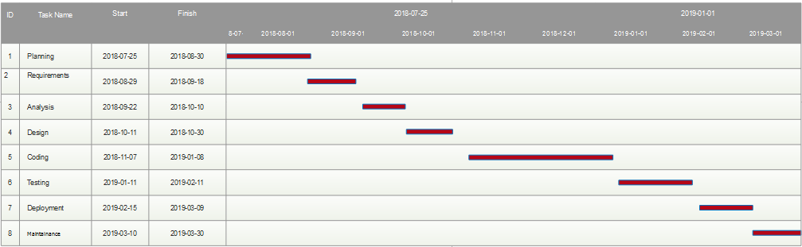

**Fig.Gantt Chart**

**FASHION WORLD**

* 1. **HARDWAREUSED**

USB

Keyboard 32- bit Processor USB Mouse

2GB RAM (minimum) 1GB Hard Disk space

* 1. **SOFTWARE USED**

PHP 5+

WordPress Installer WooCommerce Plugin

PHP My Admin

MySQL Database Server

* 1. **CONCEPTUAL MODELS**

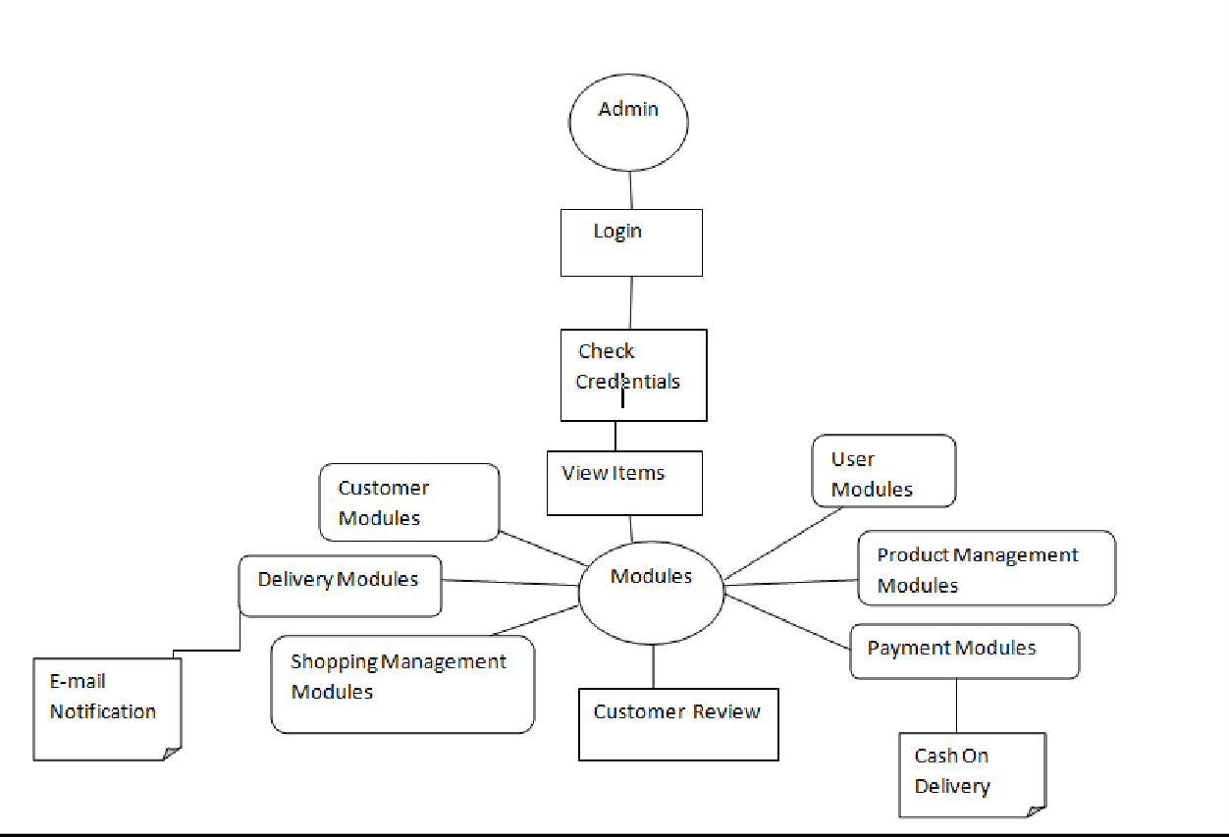

**FIG. CONCEPTUAL MODEL**

**CHAPTER 4 SYSTEM DESIGN**

* 1. **DESIGN:**

Customers are attracted to online shopping not only because of high levels of convenience, but also because of broader selections, competitive pricing, and greater access to information.

Business organizations seek to offer online shopping not only because it is of much lower cost compared to bricks and mortar stores, but also because it offers access to a worldwide market, increases customer value, and builds sustainable capabilities.

### Design Goals:

* The design of the web application involves the design of the forms for listing the products, search for products, display the complete specification for the product, and design a shopping cart that is easy to use.
* Design of an interactive application that enables the user to filter the products based on different parameters.
* Design of an application that has features like drag and drop etc.
* Design of application that decreases data transfers between the client and the server.

## DFD FOR ONLINE SHOPPING WEBSITE

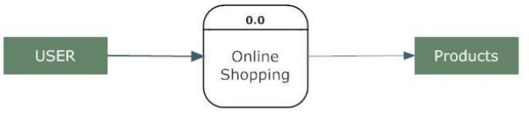

#### FIG. ZERO LEVEL DFD

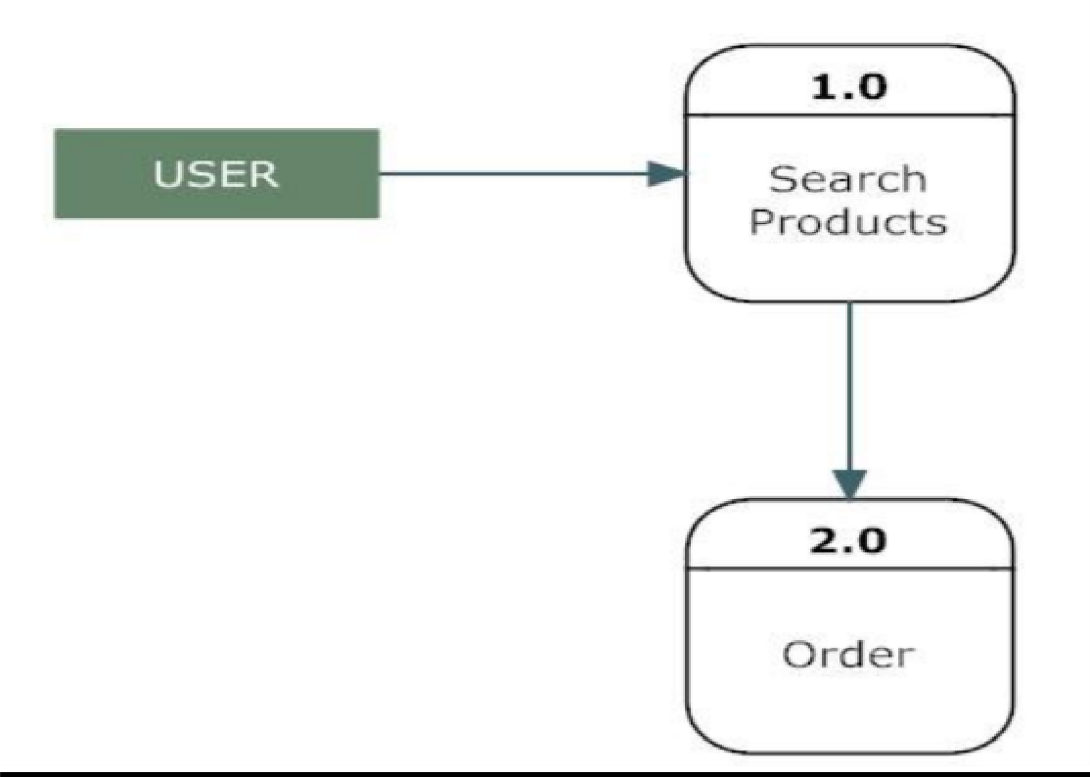

**FIG. DATA FLOW DIAGRAM**

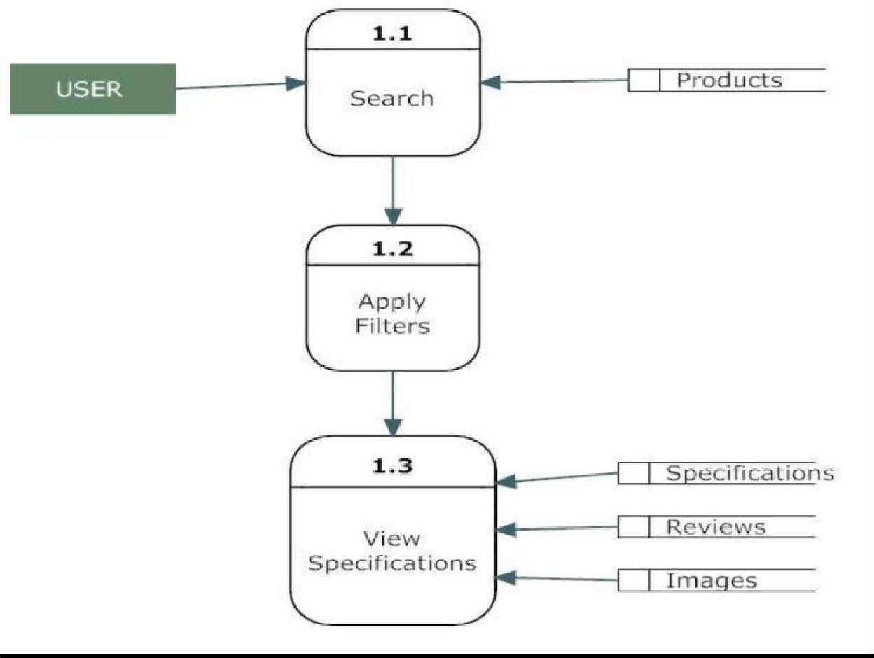

**FIG. FIRST LEVEL DFD**

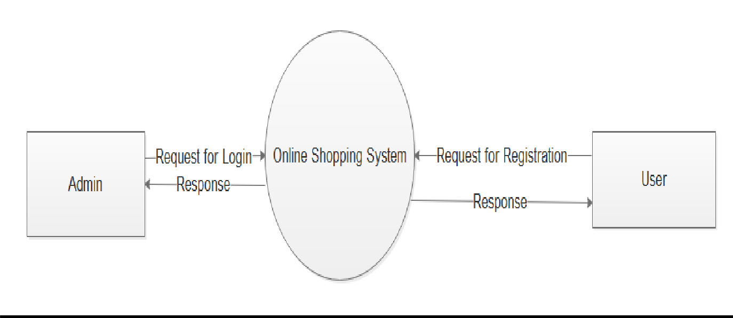

**FIG. ADMIN USER ROLE**

* 1. **DESCRIPTION OF ARCHITECTURAL DESIGN**

In this context diagram, the information provided to and received from the ‘Online Shopping’ is identified. The arrows represent the information received or generated by the application. The closed boxes represent the set of sources and sinks of information.

In the system, we can observe that the user interacts with the application through a graphical user interface. The inputs to the system are the Search and Filter criteria provided by the user and a new review written by the user. Also, the output is in the form of Repeater and grid views which present the users with list of Products available. The users can view complete specification, view Images and reviews by other users.

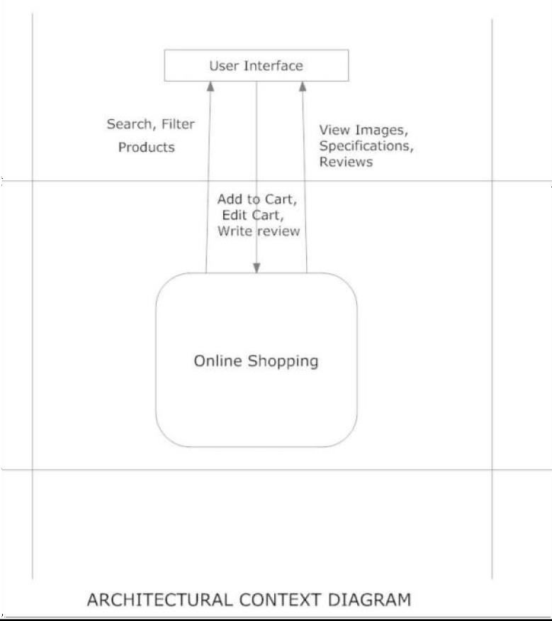

**FIG. ARCITECTURAL CONTEXT DIAGRA**

#### FASHION WORLD

* 1. **PROCEDURAL/MODULAR APPROACH**

Following are all the modules designed for the Online Shopping System.

**Admin Module**

The Admin side DFD describes the functionality of Admin , Admin is a owner of the website. Admin can first add category of item and then add items by category wise. and admin can manage order and payment detail.

### User Module

The user is all people who operate or visit our website. User is a customer of a website. User can first select product for buy, user must have to register in our system for purchase any item from our website. after register he can login to site and buy item by making online payment through any bank debit card or cash on delivery.

### Product Description Module

This module starts when a user visits the product description page. A user can view various images of the product of different sizes. The user can see an enlarged image in a popup window. The user can view the complete specification of the product like its features, operating system supported, system requirements etc. A user can also view the manufacturer information and also information about rebates, exchange policies etc. A user can also view the reviews of the product. A user can also write a review for the product.

#### FASHION WORLD

* 1. **FLOW CHART OF SYSTEM**

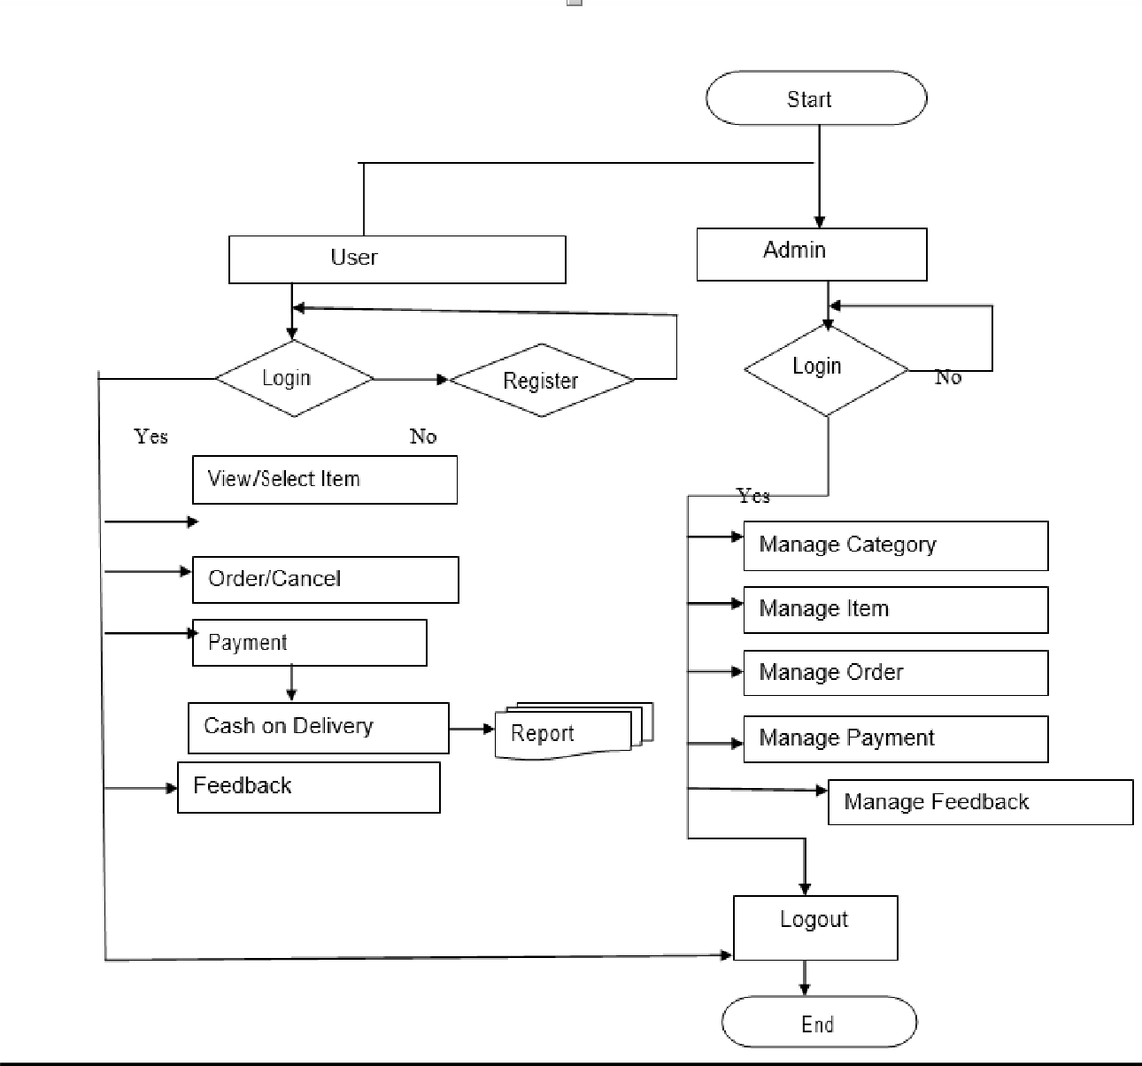

**FIG. FLOW CHART**

**FASHION WORLD**

* 1. **USER SIDE FUNCTION**

1. Registered User : (Customer, Administrator)
2. Login System (Username & Password)
3. Customer
   * Fill the Form (with the required Customer Information)
   * Display Old Orders& select one of them to display it’s items
   * Start New Orders & select required product and quantity
   * Fill Payment Details and send order

## ADMIN SIDE FUNCTION

* Display Product Details and add new products.
* Display Category list and can add/modify theme.
* Create, Modify & Display main category.
* Create Modify & Display payment type.
* Register new admin employee (Creates user ID’s for the admin and Employees in order to login).
* Change current user password after login.
* Display customer orders.
* Create, Modify & Display Country Information.

#### FASHION WORLD

* 1. **USE CASE DIAGRAM FOR ONLINE SHOPPING SYSTEM**

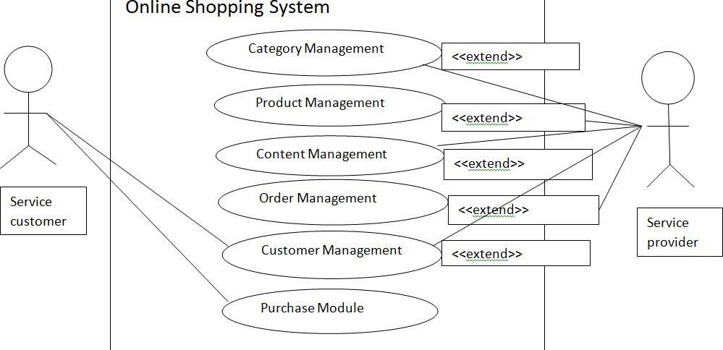

**FIG. USE CASE DIAGRAM**

**FASHION WORLD**

* 1. **ZERO LEVEL DFD – ONLINE SHOPPING SYSTEM**

Online Shopping

System

Order Management

System User Management

Payment Management

Shopping Management

Customer Management

**FIG. ZERO LEVEL DFD DIAGRAM**

Login Management

* 1. **USER INTERFACE(UI)**

The most important factors determining whether customers return to a website are ease of use and the presence of user-friendly features. [Usability](https://en.wikipedia.org/wiki/Usability) testing is important for finding problems and improvements in a web site. Methods for evaluating usability include [heuristic evaluation,](https://en.wikipedia.org/wiki/Heuristic_evaluation) cognitive walkthrough, and [user testing.](https://en.wikipedia.org/wiki/User_testing) Each technique has its own characteristics and emphasizes different aspects of the user experience.

**Algorithm steps to be processed in a designed system**

1. First you'll choose a unique domain name.
2. Then you'll pick a template and customize your **design** to match your brands colors and fonts.
3. Next, fill out your **store** settings.

Add your product photos and descriptions, and you're ready to start taking orders

# CHAPTER 5 IMPLEMENTATION AND TESTING

## IMPLEMENTATION APPROACHES

The business-to- consumer aspect of an online shopping is the most visible business use of the World Wide Web. The primary goal of an online shopping site is to sell goods and services online. This project deals with developing an e- commerce website for online shopping. It provides the user with a catalogue of different goods and services available for purchase in the store. In order to facilitate online purchase a shopping cart is provided to the user.

The system is implemented using a 3- tier approach, with a backend database, a middle tier of Microsoft Internet Information Services (MIIS) and PHP, and a web browser as the front end client. In order to develop an e- commerce website for online shopping, a number of Technologies must be studied and understood. These include multi- tiered architecture, server and client side scripting techniques, implementation technologies such as WordPress and relational databases (such as MySQL, Access).

This is a project with the objective to develop a basic website where a consumer is provided with a shopping cart application and also to know about the technologies used to develop such an application. This document will discuss each of the underlying technologies to create and implement an e-commerce website for online shopping.

## Algorithm for testing approach

#### Step 1 :

Initialization Username and Password.

#### Step 2 :

Check the Username and Password. If Invalid Username and Password then Go To Step 1 otherwise Go To Step 3.

#### Step 3 :

Check Enter Operator is Admin or User. If User Go To Step 4 otherwise Go To Step 8.

#### Step 4 :

If create a new user Go To step 5 otherwise Go To Step 6.

#### Step 5 :

Fill up the information in registration form and create a Username and Password and fill up other information of this new User. Go To Step 9.

#### Step 6:

Written detail of following in the User table.

Firstname, Lastname, Address, City, State, Zip-code, Contact no, Email id and ISAdmin

#### Step 7 :

If Request Issue then Update user ISAdmin or not information and entry in the User table. Go To Step 9.

#### Step 8 :

Go To Step 6.

#### Step 9 :

End.

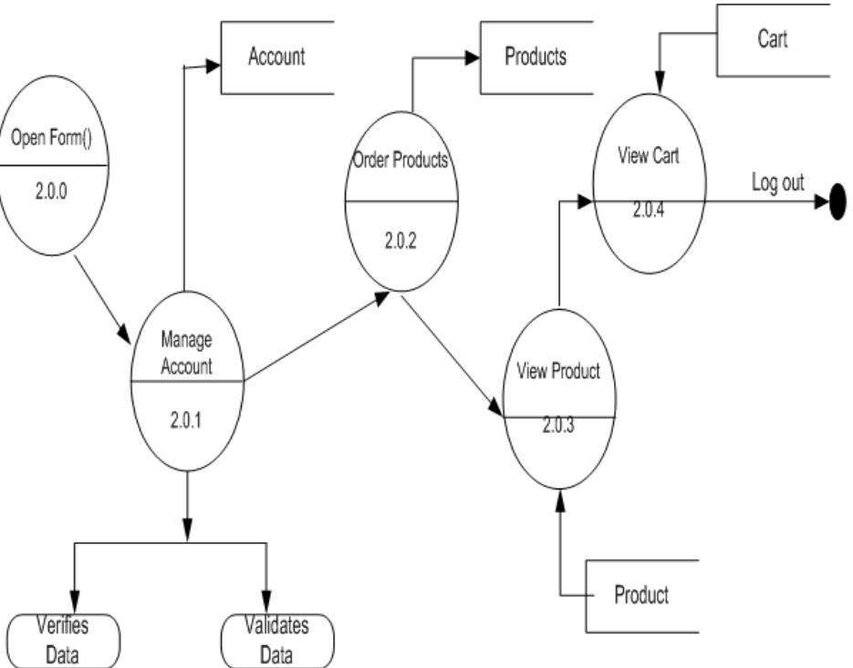

#### FIG. BASIC DFD DIAGRAM FOR WORKING SCENARIO

**RELATIONSHIP**

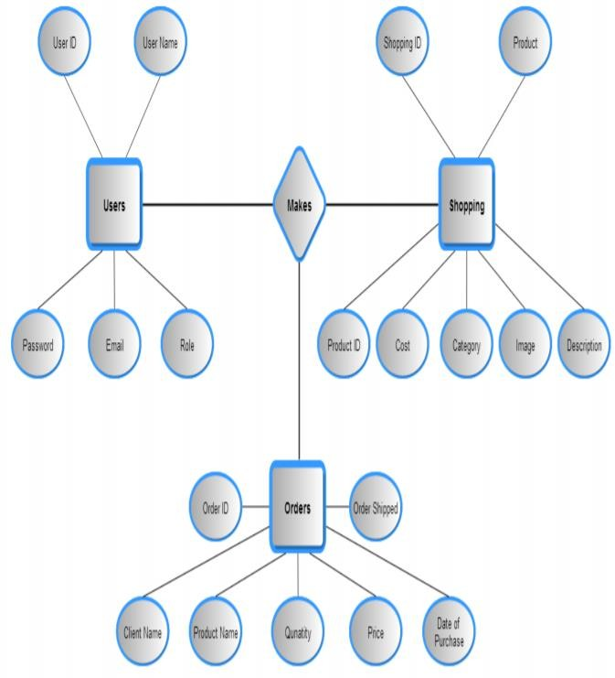

**FIG. RELATIONSHIP DIAGRAM**

* + 1. **Coding Details and Code Efficiency**

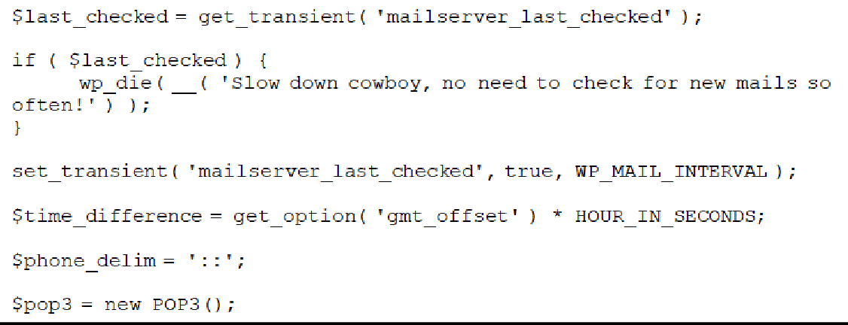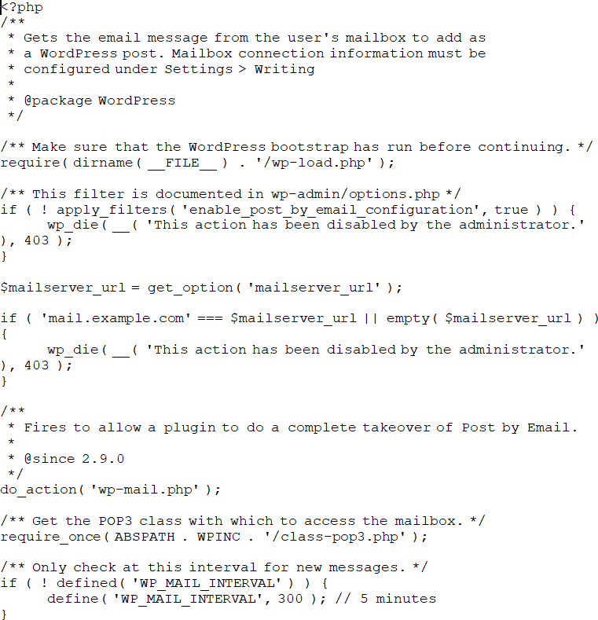

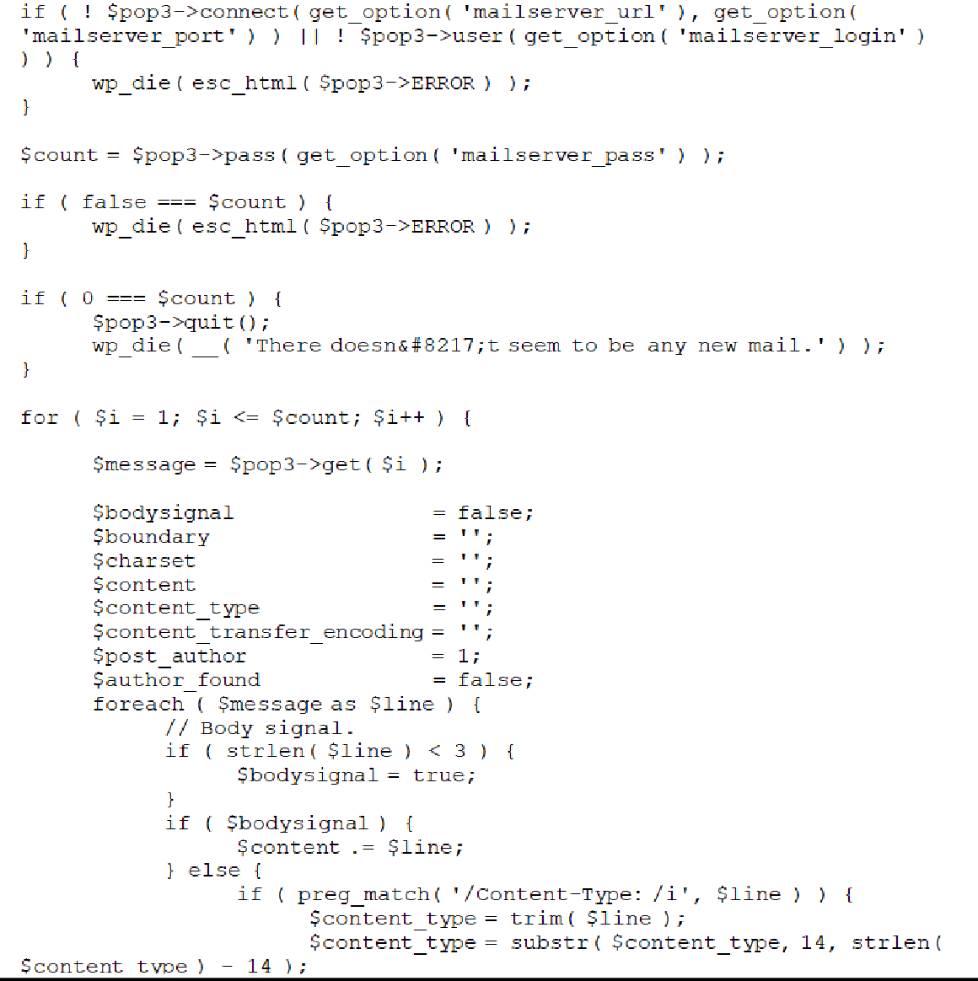

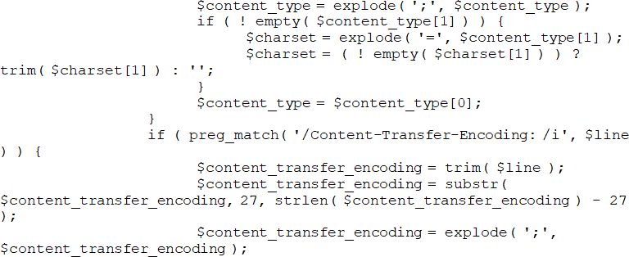

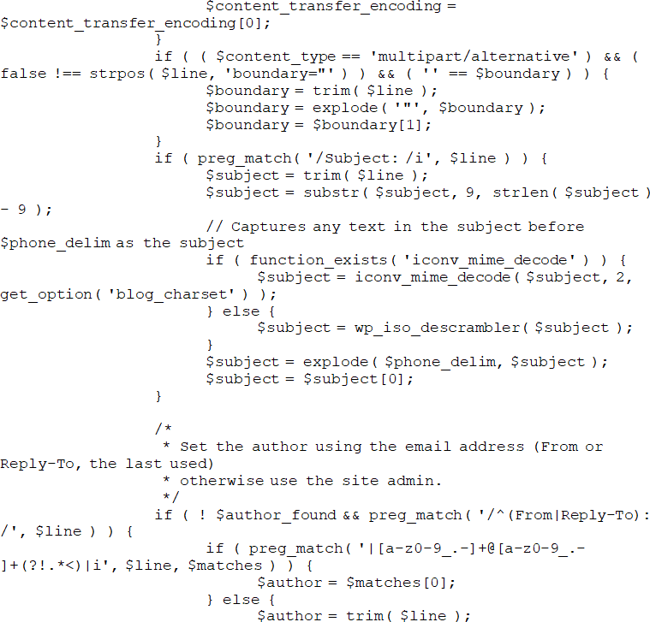

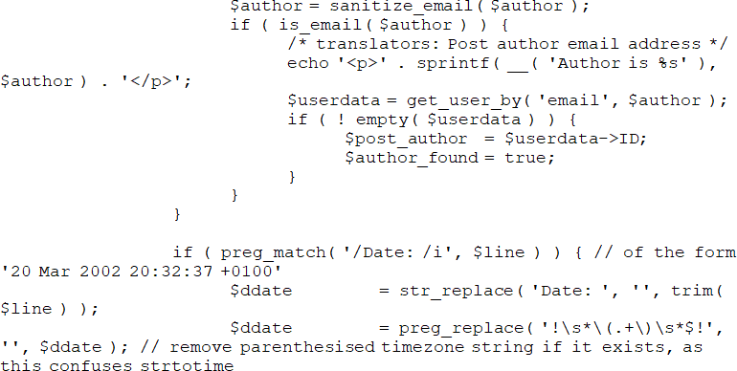

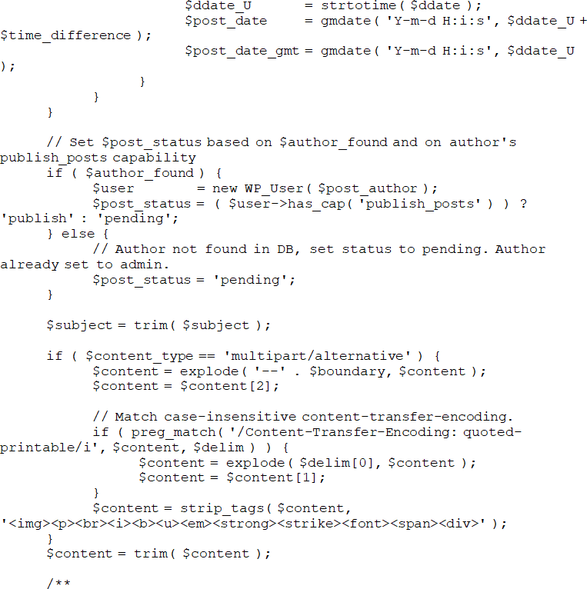

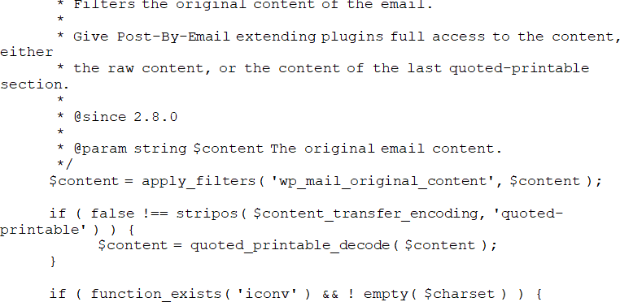

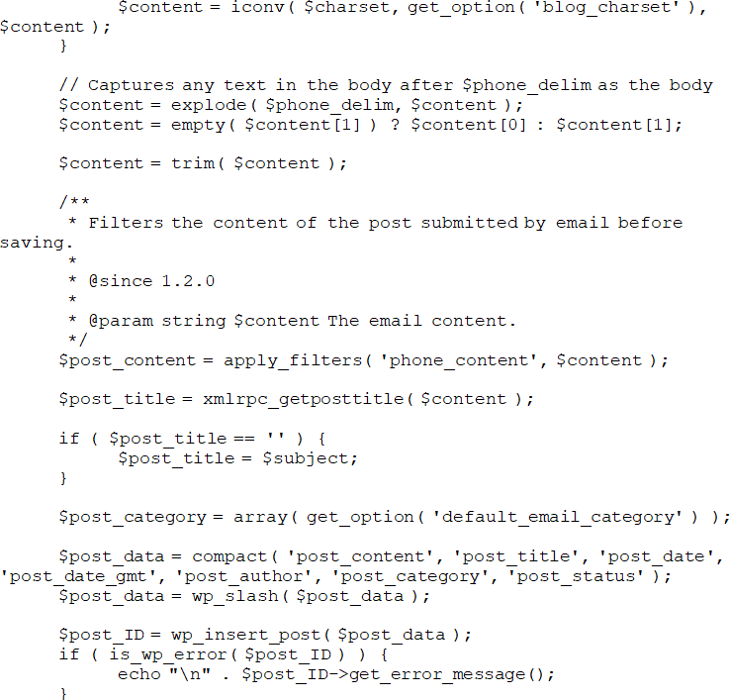

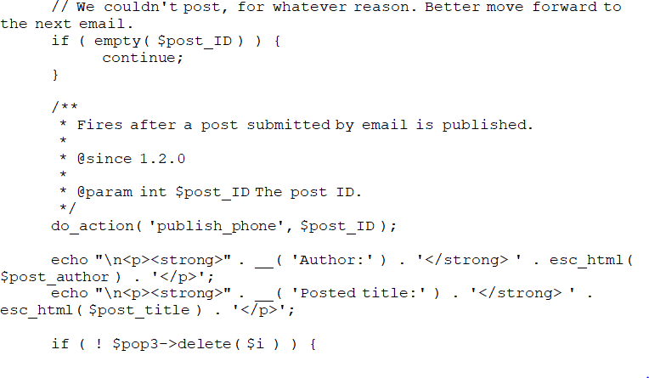

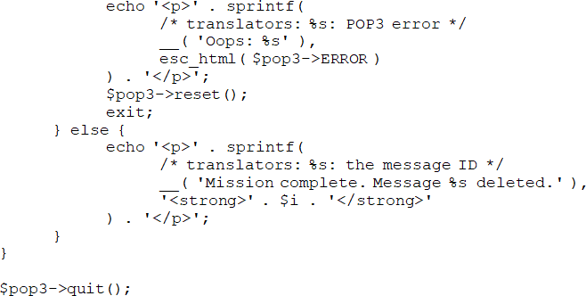

The output generated by the above code:

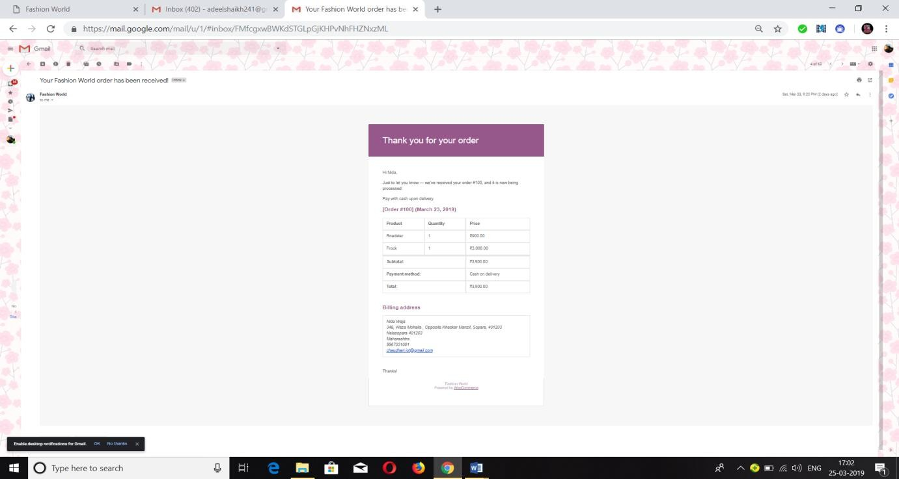

**EMAIL notification received to customer**

#### FIG. EMAIL NOTIFICATION

* 1. **TESTING APPROACH**

**TESTING**

Software testing is a process of running with intent of finding errors in software. Software testing assures the quality of software and represents final review of other phases of software like specification, design, code generation etc.

### UNIT TESTING

Unit testing emphasizes the verification effort on the smallest unit of software design

i.e. a software component or module. Unit testing is a dynamic method for verification, where program is actually compiled and executed. Unit testing is performed in parallel with the coding phase. Unit testing tests units or modules not the whole software. I have tested each view/module of the application individually. As the modules were build up testing was simultaneously tracking out each and every kind of input and checking the corresponding output until module is working correctly.

The functionality of the modules was also tested as separate units. Each of the modules was tested as separate unit. In each module all the functionalities were tested in isolation. In the shop product module when a product has been added to cart it has been made sure that if the item already exists in the shopping cart then the quantity is increase by one else a new item is created in the cart. Also the state of the system after a product has been dragged into the shopping cart is same as the state of the system if it was added by clicking add to cart button.

Also it has been ensured that all images of the products displayed in the shop products page are drag gable and have the product Property so that they can be dropped in the cart area. In the Product description module it has been tested that all the images are displayed properly. In the Cart Details it has been tested that when a user edits a quantity or removes a product from the cart, the total price is updated accordingly. It has been checked to see if the whole page refreshes or a partial page update happens when a user edits the cart.

#### FASHION WORLD

* + 1. **INTEGRATION TESTING**

In integration testing a system consisting of different modules is testedfor problems arising from component interaction .Integration testing should be developed the system specification. Firstly, a minimum configuration must be integrated and tested. In my project I have done integration testing in a bottom up fashion i.e. in this project I have started construction and testing with atomic modules. After unit testing the modules are integrated one by one and then tested the system for problems arising from component interaction.

### Validation Testing

It provides final assurances that software meets all functional, behavioral & performance requirement. Black box testing techniques are used. There are three main components -Validation test criteria (no. in place of no. & char in place of char) Configuration review (to ensure the completeness of s/w configuration.)

### Alpha Beta Testing

Alpha testing is done at developer’s site i.e. at home and Beta testing once it is deployed. Since I have not deployed my applications, I could not do the Beta testing.

### Big Bang Testing

Big Bang Testing is an approach to Integration Testing where all or most of the units are combined together and tested at one go. This approach is taken to test the complete functionality of my website to avoid uncertain actions during execution of website.

### TEST CASES

I have used a number of test cases for testing the product. There were different case for which different inputs were used to check whether desired output is produced or not.

Here, is an example of test cases of User Login and Registration.

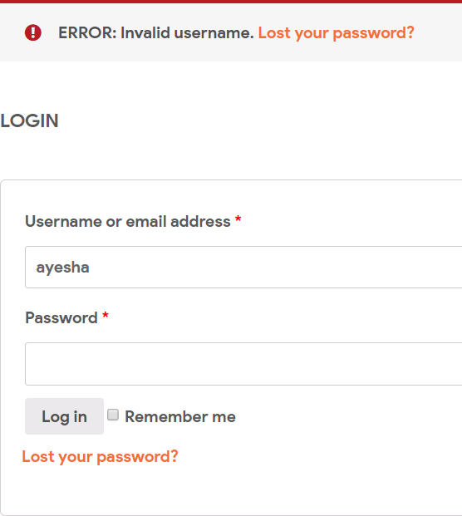

#### Fig. Testing of Login Page with Invalid Username prompts Error message

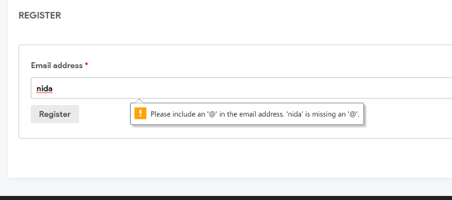

**Fig. Testing of Registration with Invalid address prompts include message**

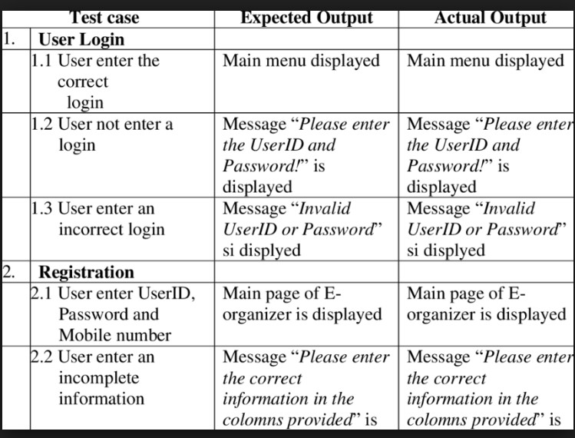

**Other Test Cases such as:**

1. Addition of a new product to the cart should create a new row in the shopping cart.
2. Addition of an existing product to the cart has to update the quantity of the product.
3. Any changes to items in the cart have to update the summary correctly.
4. Because same page is inserting data into more than one table in the database atomicity of the transaction is tested.
5. The state of the system after a product has been dragged into the cart should be same as the state of the system if the same product is added to the cart by clicking button.

# CHAPTER 6 RESULTS AND DISCUSSION

## Results and Challenges

The application can be used for any Ecommerce application. It is easy to use, since it uses the GUI provided in the user dialog. User friendly screens are provided. The application is easy to use and interactive making online shopping a recreational activity for users. It has been thoroughly tested and implemented successfully.

**Challenges**

To remain on Safer Edge and deliver the desired results to the customer we need to shift the focus on quality and performance of our E-commerce website while shrinking timeline as much as possible

E-commerce websites are much entangled in nature, automating each action is not possible because we cannot assume the nature of the customer.

Continuous changes for e-commerce demands Regression so run regression test suit every day to keep track the effects of change.

Homepage of E-commerce Website is very important and contents many information and 1000 of links associated with each product and these links grow up every day as new offers or product is added to a page.

When you are executing test scripts on a different browser at the same time. If a product is added to shopping cart or removed that information should be reflected in other browsers too.

Security Testing is where customer trust is gained on which e-commerce is built so here you have to spend a lot of time testing on DENIAL OF SERVICE ATTACK, User Account security, Data confidentiality, content security, credit card security, disable non-essential services.SSL Certificate Validation.

Don’t neglect to verify each product details and pricing details whether it is 10 products or 1000 products it should be as per the seller requirement. This is the phase where you can make or break a customer slight mistake will lead to a big loss.

## Test Report

#### Efficiency and Maintainability

* + - Page loads should be returned and formatted in a timely fashion depending on the request being made.
    - Administrators will have the ability to edit the aspects of the order forms, product descriptions, prices and website directly

#### Security

* + - Pages of the website must be access in the way they were intended to be accessed. Included files shall not be accessed outside of their parent file.
    - Administrator can only perform administrative task on pages they are privileged to access. Customers will not be allowed to access the administrator pages.

## User Documentation

* + - Any member can register and view available products.
    - Only registered member can purchase multiple products regardless of quantity.
    - ContactUs page is available to contact Admin for queries.
    - There are three roles available: Visitor, User and Admin.
      * Visitor can view available products.
      * User can view and purchase products.
      * An Admin has some extra privilege including all privilege of visitor and user
        + Admin can add products, edit product information and add/remove product.
        + Admin can add user, edit user information and can remove user.
        + Admin can ship order to user based on order placed by sending confirmation mail.

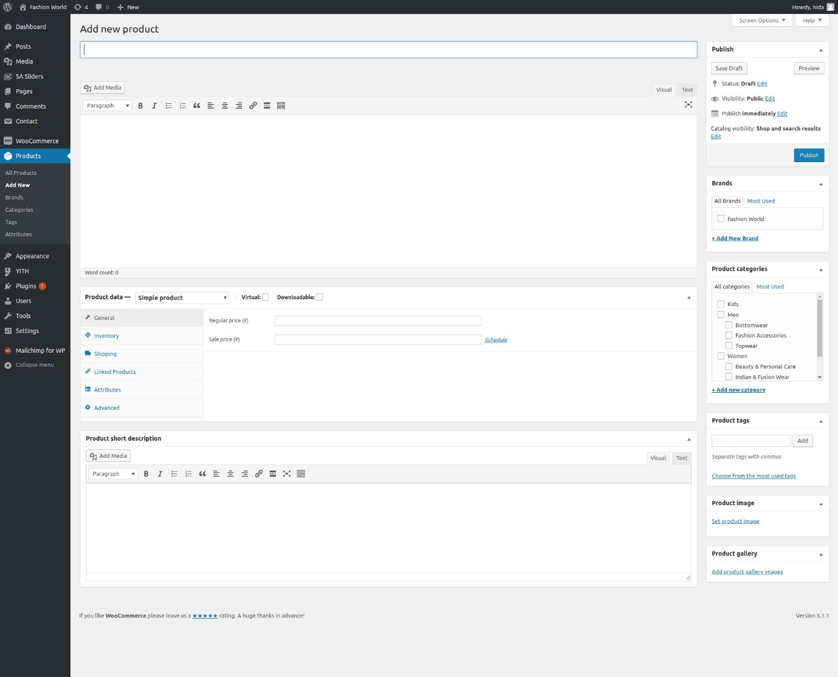

### Fig. Admin—Adds new product

Admin can add new product and multiple product

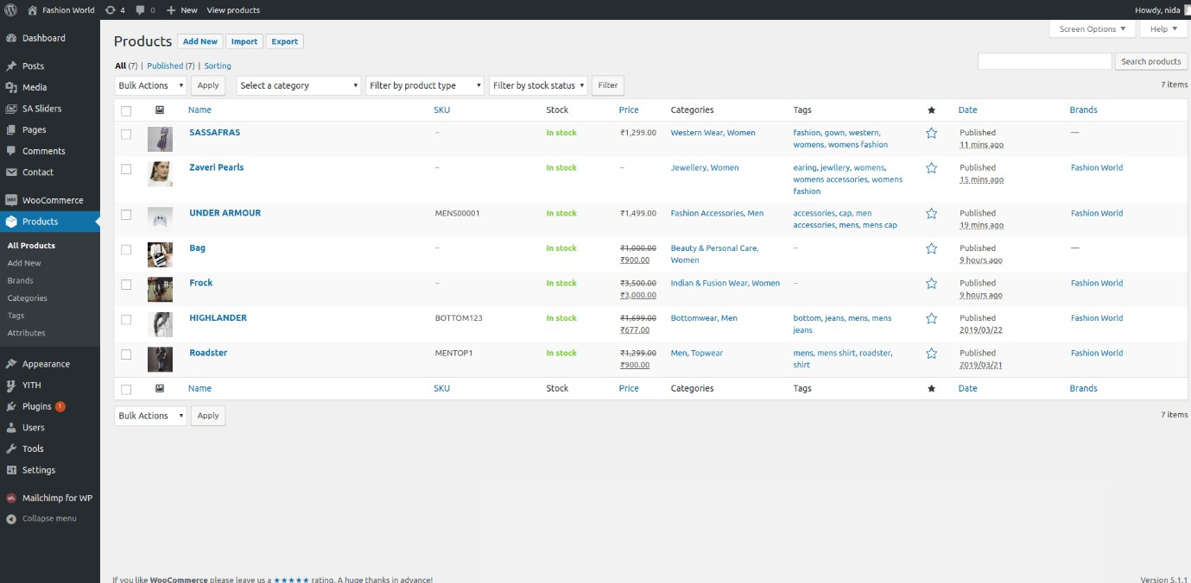

### Fig. Admin—All products

Admin can view all the products

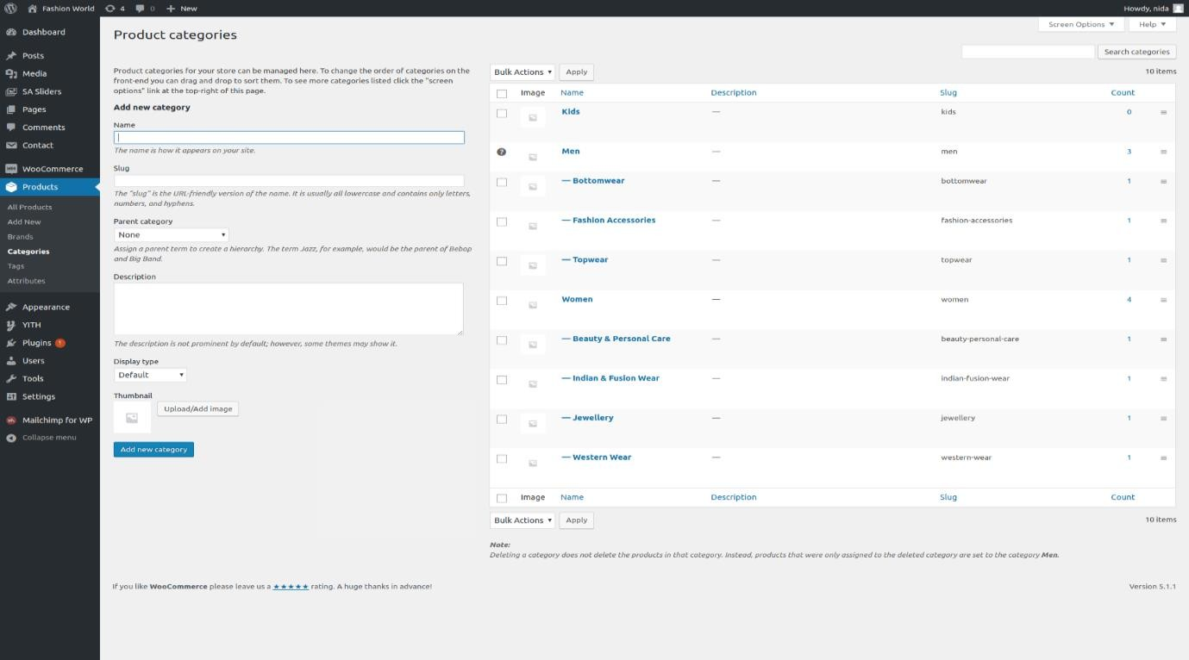

### Fig. Admin—Product Category

Admin can add product according to the product category

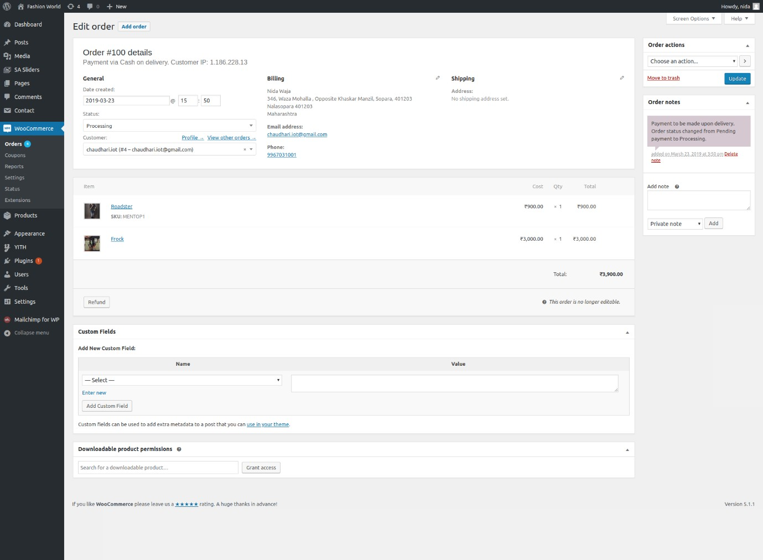

### Fig. Admin—Order Detail Page

Admin can view complete order detail

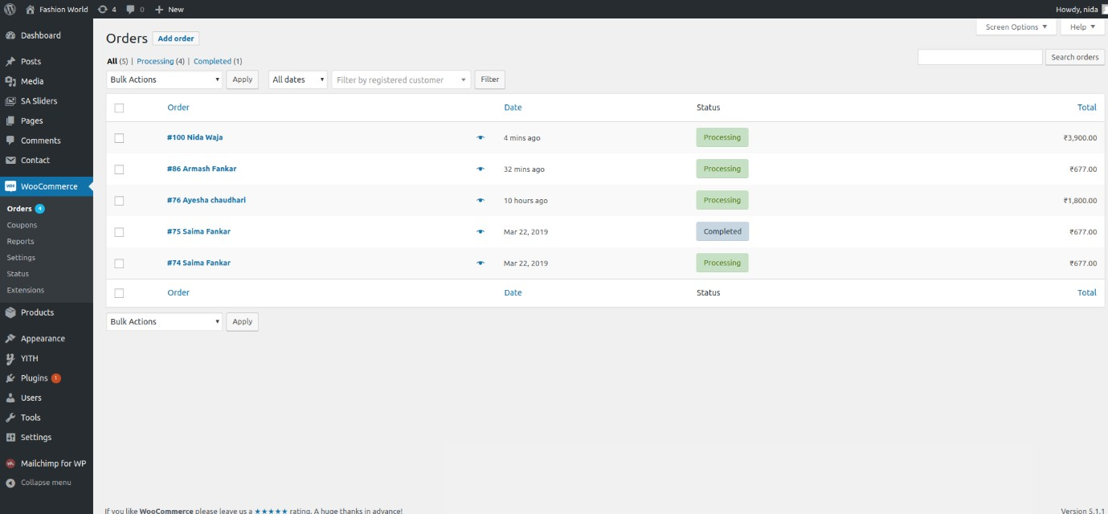

### Fig. Admin—Orders Page

Admin can view new and previous order product

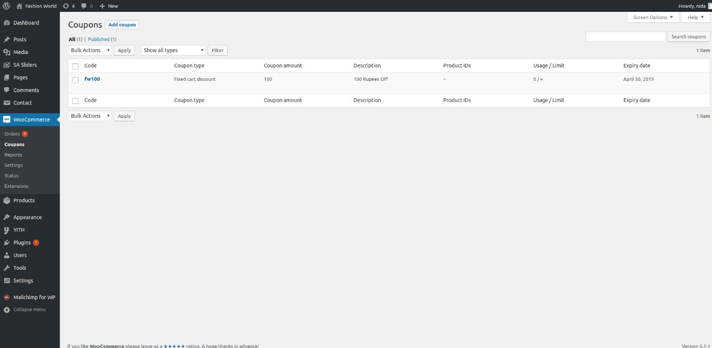

### Fig. Admin—Coupons

Admin can also give discounts using coupons

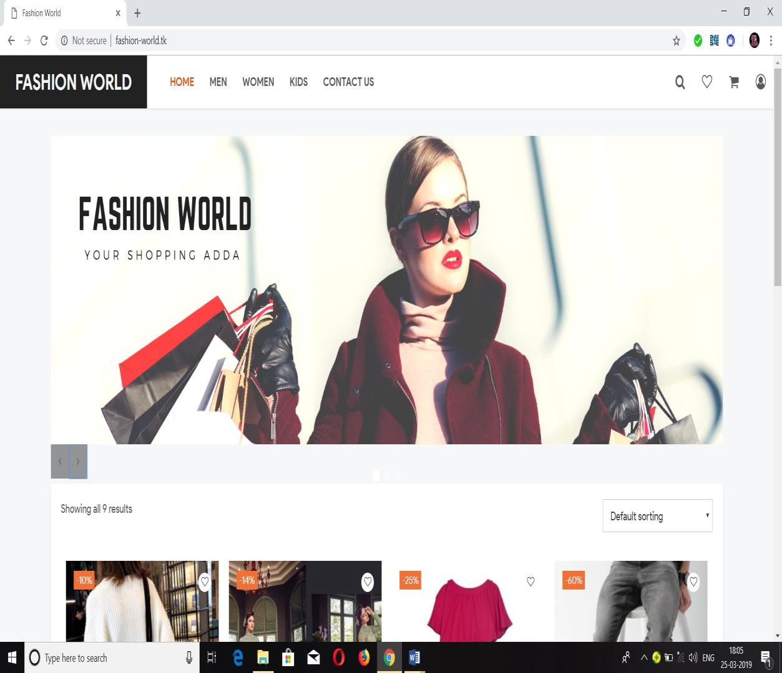

### Fig. Home Page

The home page of online shopping website

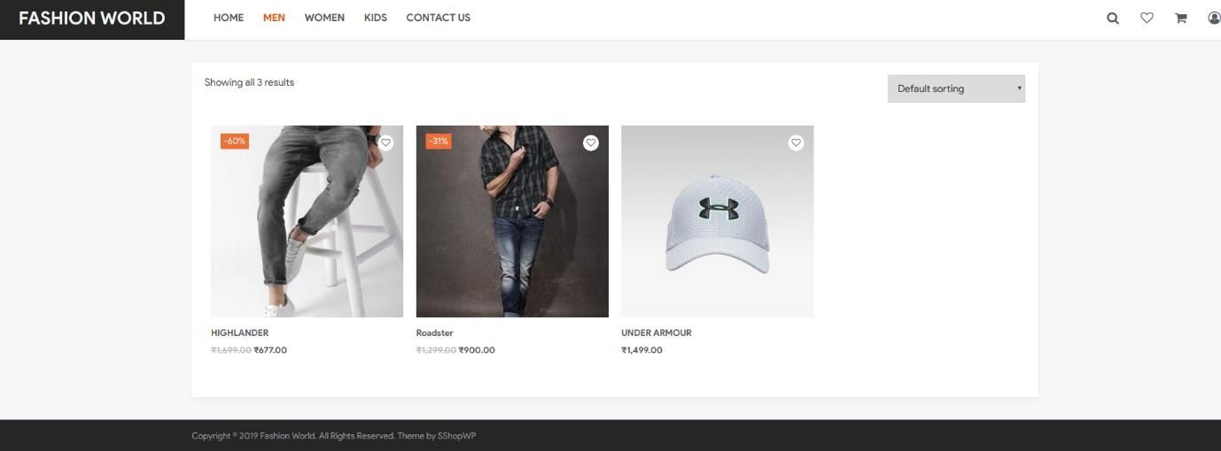

### Fig. Men Category

Men’s wear is included in men category

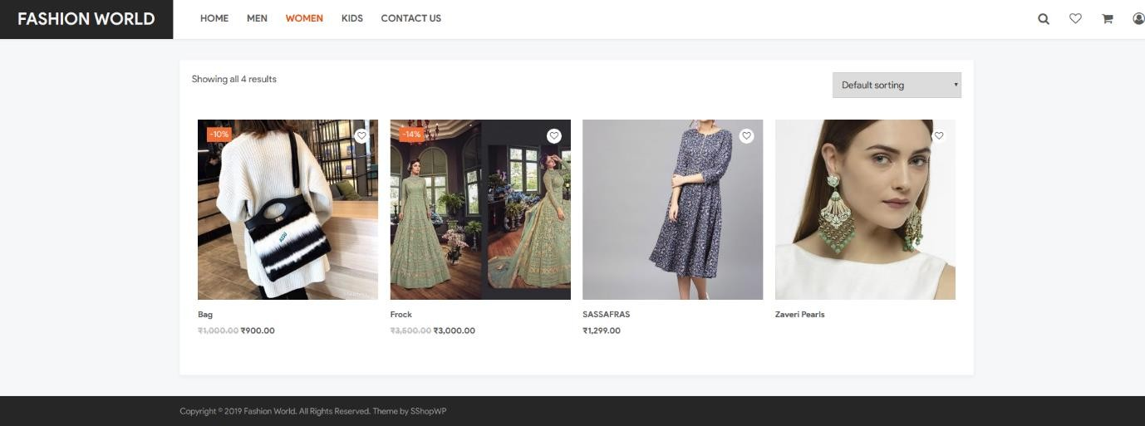

### Fig. Women Category

Women’s wear is included in women category

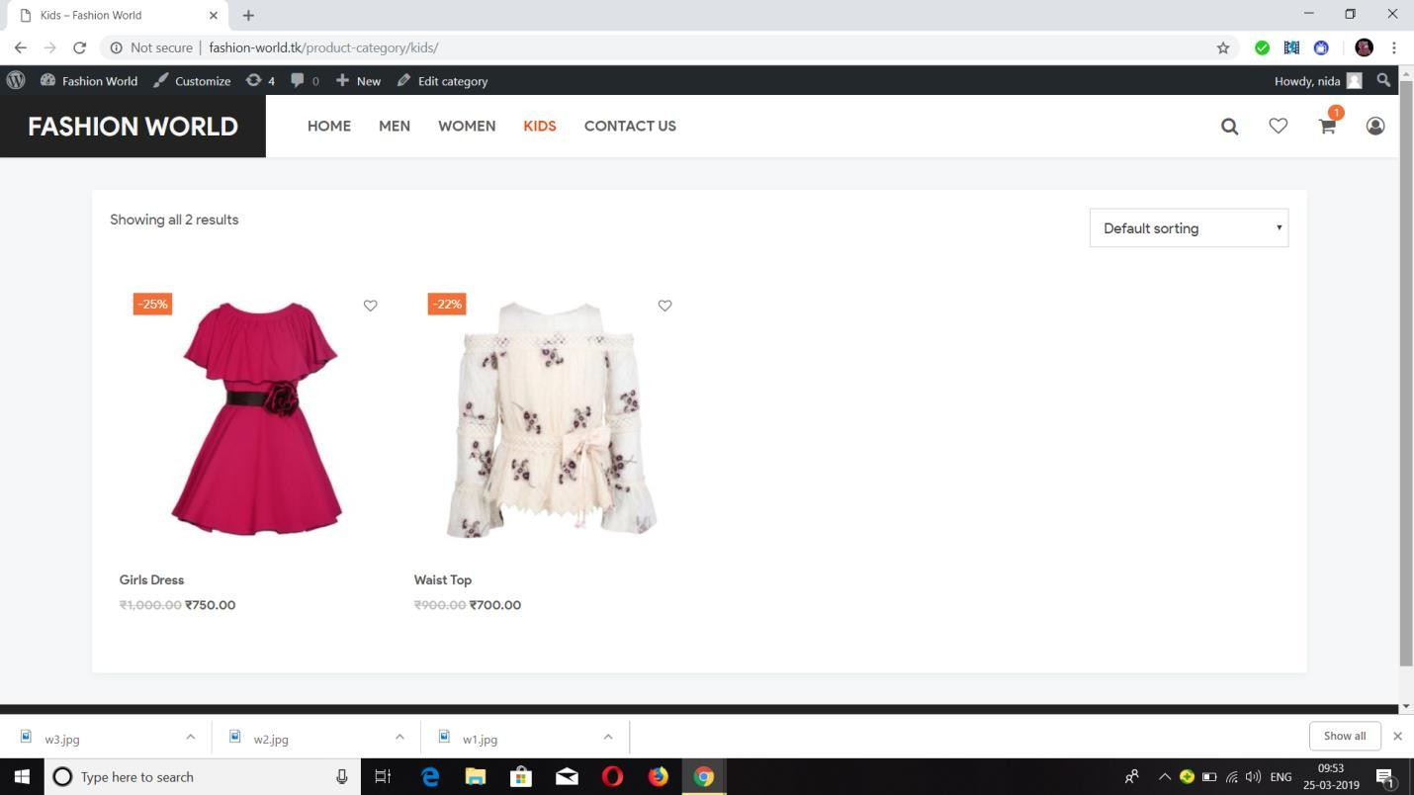

### Fig. Kids Category

Kids wear is included in kids category

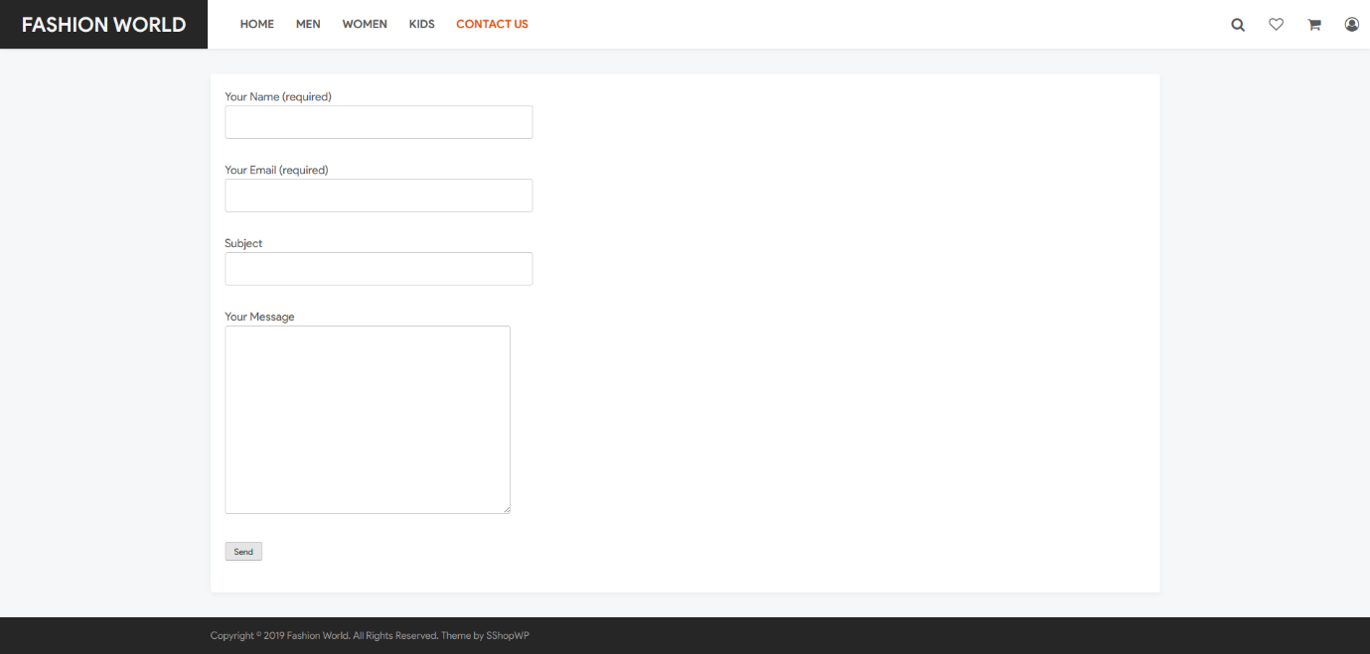

### Fig. Contact Us

The customer can give reviews and feedback

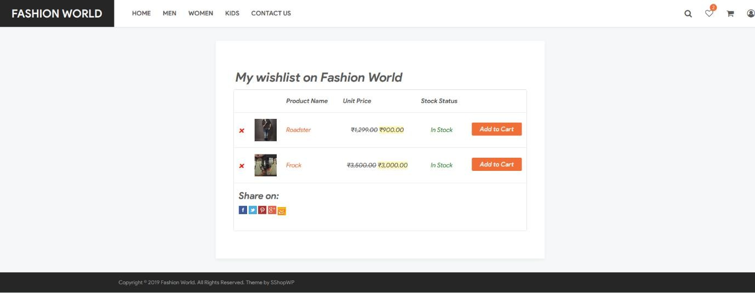

### Fig. Wishlist

The customer can add the product of their choice in the wishlist

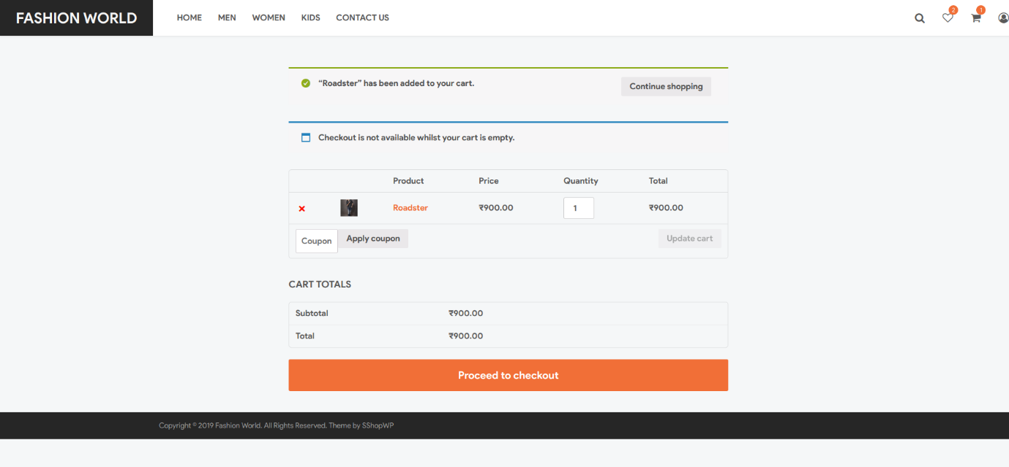

### Fig. Cart

To buy the product, the customer has to put it on the cart

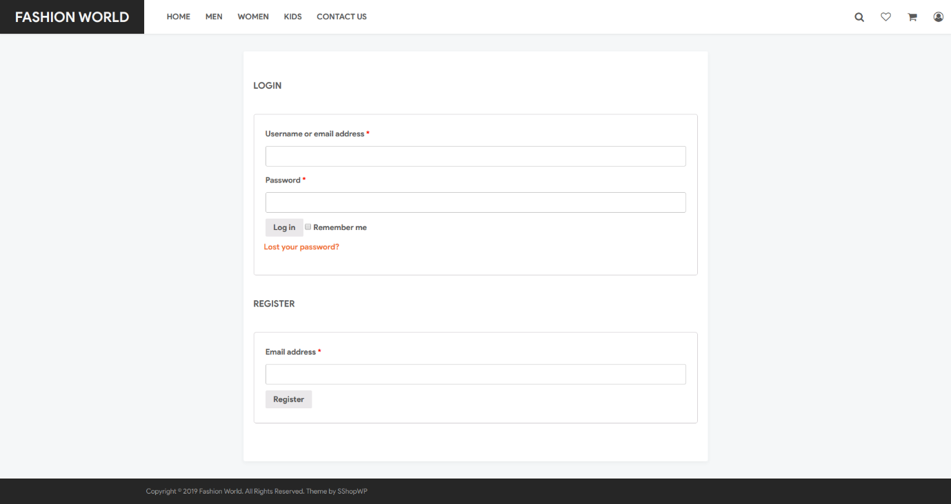

### Fig. Login and Signup

Admin can signup from customer page

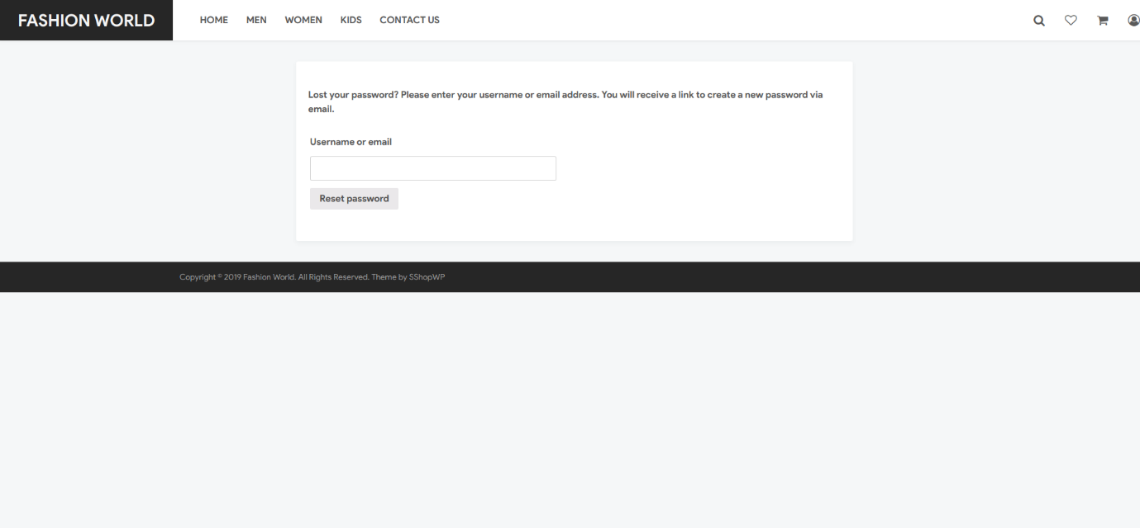

### Fig. Forgot Password Page

If customer forgets password he/she can use the forgot password page

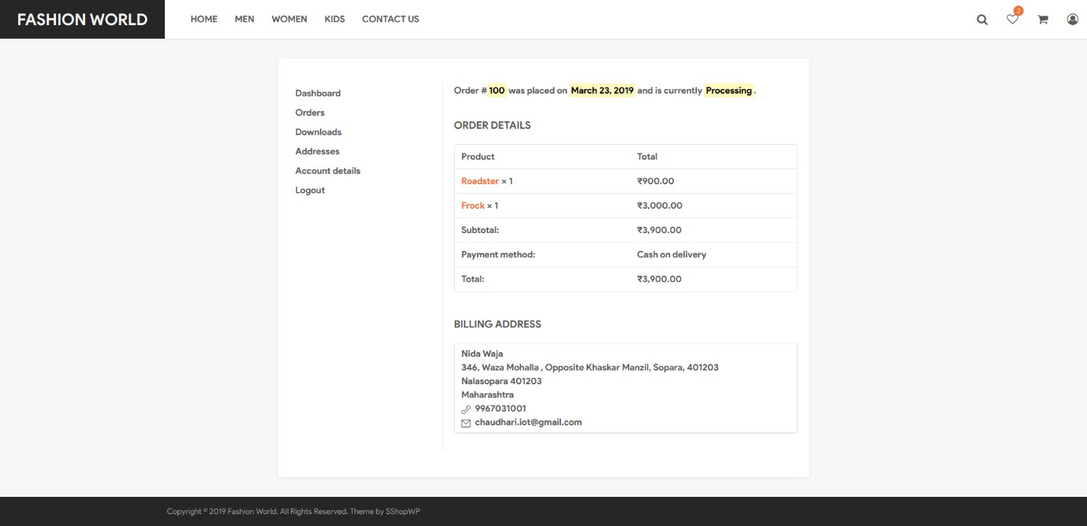

### Fig. Order Configuration Page

The customer gets the confirmation message

# CHAPTER 7 CONCLUSION AND FUTURE WORK

## CONCLUSION

The Internet has become a major resource in modern business, thus electronic shopping has gained significance not only from the entrepreneur’s but also from the customer’s point of view. For the entrepreneur, electronic shopping generates new business opportunities and for the customer, it makes comparative shopping possible. As per a survey, most consumers of online stores are impulsive and usually make a decision to stay on a site within the first few seconds. “Website design is like a shop interior. If the shop looks poor or like hundreds of other shops the customer is most likely to skip to the other site. Hence we have designed the project to provide the user with easy navigation, retrieval of data and necessary feedback as much as possible. In this project, the user is provided with an ecommerce web site that can be used to buy books online. To implement this as a web application we used WordPress as the technology with WooCommerce Plugins has several advantages such as enhanced performance, scalability, built-in security and simplicity.

A good shopping cart design must be accompanied with user-friendly shopping cart application logic. It should be convenient for the customer to view the contents of their cart and to be able to remove or add items to their cart. The shopping cart application described in this project provides a number of features that are designed to make the customer more comfortable.

This project helps in understanding the creation of an interactive web page and the technologies used to implement it. The building of the project has given me a precise knowledge about how WordPress is used to develop a website, how it connects to the database to access the data and how the data and web pages are modified to provide the user with a shopping cart application.

## LIMITATION

The software we have developed have some limitation. We are trying to fulfill all requirements. But some tasks are not done here. Real time services like voice, chatting and video conferencing are not done here. The system is developed for only cash on delivery as payment method. PayPal not added just added to show it. Upcoming product will display only website but not added messaging service that when any product will come will send message to customer mobile that new product available.

## SCOPE FOR FUTURE WORK

If its limitation can be solved then it would be more effective. In future we will try to develop our project so that we able to give these facilities and credit card validation is not done. The administrator of the website can be given more functionality, looking specific customer generate invoice from admin panel of customer till present for taking decision. Adding SMS gateway to confirm that customer order successfully submitted, and also the current stats of order that means any state change of order customer will get a notification.

The following things can be done in future to enhance our website to create a user- friendly scope and useful for the customers.

* + - The current system can be extended to allow users to create accounts and save products in to wish list.
    - The users could subscribe for price alerts which would enable them to receive messages when price for products fall below a particular level.
    - The current system is confined only to the shopping cart process. It can be extended to have an easy to use check out process.
    - Most generic consumer to consumer e-commerce website,which covers almost all possible categories.
    - Maximize benefits and minimize the disadvantages of a common e- commerce website.
    - User friendly, Vendor friendly environment.

# CHAPTER 8 REFERENCES

## REFERENCES

* + [**https://wordpress.org/**](https://wordpress.org/)
  + [**https://en.wikipedia.org/wiki/WordPress**](https://en.wikipedia.org/wiki/WordPress)
  + [**https://en.wikipedia.org/wiki/MySQL**](https://en.wikipedia.org/wiki/MySQL)
  + [**https://en.wikipedia.org/wiki/PHP**](https://en.wikipedia.org/wiki/PHP)
  + [**https://www.tutorialspoint.com/wordpress/**](https://www.tutorialspoint.com/wordpress/)
  + [**https://www.youtube.com/watch?v=EXKwAk0j3k8**](https://www.youtube.com/watch?v=EXKwAk0j3k8)
  + [Step-By-Step WordPress for Beginners](https://www.amazon.com/dp/B01M9GYDDG/?tag=bdc_businessdotcom-20) **-** The book is a complete training guide that helps readers setup their first website using WordPress.
  + [WordPress for Small Business](https://www.amazon.com/Wordpress-Small-Business-Strategies-Dynamic/dp/1623156270/?tag=bdc_businessdotcom-20) **–** The book about the WordPress has been the most effective CMS that helps businesses achieve this goal.